**TEACHERS’ BARRIERS AND CHALLENGES IN WRITING ACTION RESEARCH**

**A Qualitative Research**

Submitted to:

**VINCENT B. BIALEN**

Adviser

**PRINCESS GWEN NACIN**

**JONALYN MANALO**

**JUDELYN CARTICIANO**

**TRIXIE VELL DALAGON**

**JOHANNA MODAY**

**AICY JANE BAÑO**

**BERNADETTE USMAN**

**RYAN JAMES DELIM**

**JOVER POBLACION**

**CLARK JAKE GILSANA**

**JASON RAVIN**

**ALJUDEL SAHIOL**

Student-Researchers

**MAY 2023**

**TRANSMITTAL SHEET**

This research entitled **TEACHERS’ BARRIERS AND CHALLENGES IN WRITING ACTION RESEARCH,** prepared and submitted by **PRINCESS GWEN NACIN, JONALYN MANALO, JUDELYN CARTICIANO, TRIXIE VELL DALAGON, JOHANNA MODAY, AICY JANE BANO, BERNADETTE USMAN, RYAN JAMES DELIM, ALJUDEL SAHIOL, JOVER POBLACION, JASON RAVIN, CLARK JAKE GILSANA,** in Partial fulfillment of the requirements in **PRACTICAL RESEARCH I**, is hereby accepted and endorsed.

**VINCENT B. BIALEN, MAT**

Research Adviser

_______________

Date Signed

Respectfully endorsed as partial fulfillment of the requirements in **PRACTICAL RESEARCH I**

**RHEA MAY ENATE, MST LORELY ANNE F. VALENCIA, EdD.**

Research Coordinator Principal II

_____________ _____________

Date Signed Date Signed

**APPROVAL SHEET**

This research has passed the standards set by **Isulan National High School**, and has been successfully defended and approved on _________ before this panel of examiners.

**VINCENT B. BIALEN, MAT**

Research Adviser

**__________________________ _____________________________**

Member, Examining Committee Member, Examining Committee

**__________________________**

Member, Examining Committee

**LORELY ANNE F. VALENCIA, EdD.**

Chairperson, Examining Committee

**ACCEPTED** in **PARTIAL FULFILLMENT** of the requirements in **Practical Research I.**

**Acknowledgement**

The researchers would like to express their sincerity and gratitude to the following persons who contributed their expertise and support in making this study possible:

To the school principal, **Lorely Anne F. Valencia**, for giving us the permission to conduct this study.

To the research teacher, **Vincent B. Bialen**, for the motivation, guidance, and support in completing this study;

To the panelists, **Sandra S. Aquino, Elena P. Beso**, and, **Ian T. Fabrao** for the guidance, recommendations, and suggestions in making this study appropriate;

To the subject teachers, **Catherine V. Olid**, **Gretchell C. Yurag**, **Rhea A. Fernandez**, and **Ronalyn T. Legaspi** for giving vacancy in their class hours in order for us to do our research;

To the participants, **Junior and Senior High School teacher-respondents**, thank you for sparing ample time in providing the necessary data for this study;

Above all, to the almighty God, the source of everything, who have been our strength, counselor, provider and confidant in every day walks of life.

**TABLE OF CONTENTS**

**PRELIMINARY PAGES PAGE**

Title Page…………………………………………………………………………………i

Transmittal Sheet……………………………………………………………………..ii

Approval Sheet………………………………………………………………………..iii

Acknowledgment……………………………………………………………………...iv

Table of Contents………………………………………………………………………v

Lists of Figures………………………………………………………………………..vi

Lists of Appendices………………………………………………………………….vii

Abstract……………………………………………………………………………….viii

**CHAPTER I-INTRODUCTION**

Background of the Study……………………………………………………………1

Theoretical Framework………………………………………………………………2

Statement of the Problem……………………………………………………………3

Significance of the Study…………………………………………………………….3

Scope and Delimitation of the Study……………………………………………..4

Definition of Terms……………………………………………………………………4

**CHAPTER II-REVIEW OF RELATED LITERATURE AND STUDIES**

Constrains of Conducting Action Research ……………………………………………7

Teachers’ Professional Development………………………………………………….12

Addressing Teachers’ Challenges…………………………………………………….16

Synthesis……………………………………………………………………………….19

**CHAPTER III- METHODOLOGY**

Research Design……………………………………………………………………..23

Participants…………………………………………………………………………...24

Locale of the Study………………………………………………………………….25

Sampling………………………………………………………………………………26

Instrument…………………………………………………………………………….27

Procedure……………………………………………………………………………..28

Data Analysis…………………………………………………………………………29

Ethical Considerations……………………………………………………………..30

**CHAPTER IV-RESULTS AND DISCUSSION**

Research Question Number 1

Theme 1………………………………………………………………………………..31

Theme 2………………………………………………………………………………..34

Theme 3………………………………………………………………………………..36

Research Question Number 2

Theme 1………………………………………………………………………………..38

Theme 2………………………………………………………………………………..40

Theme 3………………………………………………………………………………..42

**CHAPTER V- CONCLUSION AND RECOMMENDATION**

Conclusion…………………………………………………………………………….43

Recommendation…………………………………………………………………….45

REFERENCES…………………………………………………………………………….46

APPENDICES……………………………………………………………………………..47

CURRICULUM VITAE……………………………………………………………………48

**LIST OF FIGURES**

**FIGURE NO. TITLE PAGE**

1 Map of the Locale of the Study 35

**LIST OF APPENDICES**

**APPENDIX TITLE PAGE**

A Semi-Structured Questionnaire 0

B Letter of Request to the Principal 0

C Informed Consent 0

D Thematic Narrative Analysis 0

E Documentation 0

F Curriculum Vitae 0

G Plagiarism Result 0

**Abstract**

Action research is a systematic and reflective approach employed by educators to address teaching and learning issues within their classrooms and educational settings. While action research holds great potential for professional development and improving educational practices, teachers often encounter various barriers and challenges when attempting to write action research reports. This study aims to explore and analyze the barriers and challenges faced by teachers during the process of writing action research. This study was conducted in the Second Semester of A.Y. 2022-2023 to discuss the barriers and challenges encountered by the teachers of Isulan National High School in writing action research. The research instruments used is the qualitative, descriptive phenomenology design. The results were analyzed using Colaizzi’s Thematic Narrative Analysis. The findings revealed that the main challenges encountered by the teachers were: insufficient knowledge and seminar on research; heavy teaching loads; lack of time; and busy on personal life.

**Keywords:** Action Research, Barriers and Challenges, Teachers

**CHAPTER I**

**INTRODUCTION**

**Background of the Study**

The Philippine educational system is fast evolving as a result of numerous variables such as ASEAN integration, global competitiveness, globalization, ICT integration in teaching, and other significant internal and foreign influences. With the implementation of the Department of Education’s new K-12 program across all Basic Education institutions in the Philippines, some key motivations should be considered, such as evidence-based policy, improved student achievement, curriculum, instruction, and assessment enhancement, teacher quality, and teacher professionalism (Abaya, et al. 2017). With these, many key issues should be considered for basic education institutions to meet the demands of a rapidly changing environment. One of these elements is the incorporation of action research as a primary function of a teacher in the twenty-first century (Chou, 2011; Hazelton & Haigh, 2010). Teachers must therefore embrace action research in their professional lives to build a research culture among schools to improve educational results for local and global competitiveness.

Action exploration is a methodical, group-based, and reflective inquiry approach that enables teachers to assess their own instructional strategies and make adjustments in light of their results (Lingard et. al., 2008). Teachers can pinpoint areas for development, try out new tactics, and assess the results of their efforts by following this approach. Although action research has the potential to be beneficial, many teachers are prevented from doing it due to obstacles and challenges. These challenges may include a lack of expertise in research methods, a lack of time and resources, a lack of support from colleagues or school management, and issues obtaining ethical approval.

The former studies in action research in the Philippine educational system emphasizes its significance and advantages as well as the necessity for instructors to adopt it. However, there is a gap when it comes to knowing the precise barriers and difficulties that teachers faced when writing action research. While constraints such a lack of knowledge, time, money, support, and ethical permission are briefly mentioned in the book, further study is necessary to fully comprehend these issues and how they affect teachers' capacity to do action research. Therefore, this study aims to fill the gaps by examining the barriers and challenges faced by teachers in writing action research, providing valuable insights into the factors that facilitate or hinder the implementation of action research projects in educational settings.

The problem of teachers finding it challenging to do action research is also coming up in the case of Isulan National High School. When teachers do action research, they encounter hurdles that prevent them from becoming innovative or improving their teaching methods. Action research allows participants to evaluate their teaching methods and pinpoint areas for improvement. Teachers may go on with their current methods of instruction without making the required adjustments if they are unable to do action research owing to a lack of time, money, or expertise. This may eventually harm the school's educational quality and students' learning outcomes.

The researchers are motivated to conduct this study to have a better understanding of the barriers and challenges of teachers in writing action research. In doing so, it will be possible to comprehend the elements that may either help or impede the execution of action research projects in educational settings. The practical aspects of performing action research projects, such as time restrictions and institutional regulations, can also be taught to students.

**Theoretical Framework**

The study anchors in the concept of reflective practice theory of Donald Schön (1980). According to Schön, professionals frequently encounter situations in which they are unsure of what to do or how to proceed. To make decisions under these circumstances, they must rely on their own experiences, information, and abilities. Reflecting on these experiences, recognizing areas for growth, and altering one's technique are all components of reflective practice. To improve their future teaching, teachers use reflective practice. Teachers carefully gather evidence about their teaching practice to analyze, interpret, and evaluate their experiences (Farrell, 2016; Mathew & Peechattu, 2017).

Similarly, Finlay (2008) said that reflective practice also helps to raise the caliber of teachers. One component of teacher quality that is impacted by reflective practice and a specific set of abilities within a situational setting is professional development, which is frequently characterized as how a teacher obtains specialized knowledge (Koellner & Jacobs, 2015).

Moreover, When applied to action research, (Beauchamp & Thomas, 2009) explained that reflective practice can help teachers identify and address research challenges. Teachers can identify the factors that have hindered their progress and develop new approaches to overcome these obstacles by reflecting on their experiences.

Overall, the concept of reflective practice can be a useful way to comprehend the challenges that teachers face when conducting action research and developing strategies for overcoming these challenges.

**Research Questions**

This study aims to understand the barriers and challenges of the teachers of Isulan National High School in writing action research.

Specifically, it provides answer to the following questions:

1. What are the barriers and challenges faced by Isulan National High School Teachers’ in making action research?
2. How do teachers overcome the barriers and challenges of implementing action research in their teaching practice?

**Significance of the Study**

This study will be carried out within the context of specific instructors encountering obstacles and difficulties while conducting research. The following information would be significantly supported by the results of this investigation:

To the **Students**, the result of this study can help students understand the value of action research in improving teaching and learning. They can also gain insights into the difficulties that teachers face while conducting action research, which will help them better understand the educational system.

To the **Parents**, this study can help parents understand the challenges that teachers face when conducting action research. They can also appreciate teachers who conduct action research projects to improve their teaching practices and their students’ learning outcomes.

To the **Teachers**, this study can help them identify the barriers and challenges they face while conducting action research. This can help them overcome these obstacles and improve their research skills.

To the **Future Researchers**, they can benefit from this research by better understanding the difficulties that teachers face when conducting action research. This can help them design research projects that address these challenges and improve the quality of education research.

**Scope and Delimitation**

The study will focus on the barriers and challenges faced by the teachers of Isulan National High School.

Using semi-structured interview questions, the teachers will be interviewed about their experiences, challenges, and success stories of conducting action research.

The study's participants are 9 teachers from Isulan National High School's Senior and Junior High Schools. They will be chosen on purpose.

**Definition of Terms**

**Action Research.** Refers to systematic process used by teachers to improve their teaching practices and the learning outcomes of their students. It is a tool that enables educators to evaluate their methods, create fresh approaches, and improve their instructional abilities.

**Barriers and Challenges.** Refers to the obstacles that teachers faced when conducting action research.

**Experiences and Success Stories.** Refers to the difficulties encountered and achievements of the teachers in making action research.

**Future Researchers.** Refers to the person who will carry out the same research in the future. It is also the one who will benefit from this research.

**Junior and Senior High School Program.** Refers to the main component of the K–12 Basic Education Program, which aims to provide every student with the opportunity to receive a quality education. It also refers to the four-year high school curriculum and an additional two years of basic education known as the Senior High School Program.

**K-12 Basic Education Program.** Refers to the current curricular innovation introduced by the Department of Education, which aims to provide relevant education to better prepare Filipinos for the challenges of the twenty-first century. The innovation is recognized by mandatory kindergarten and an additional two years of basic education known as the Senior High School Program.

**Reflective Practice.** Refers to the Theory that was used to support the research study.

**Teachers**. Refers to the person who teaches, especially in a school. It also refers to the person who conducts action research.

**Chapter II**

**REVIEW OF RELATED LITERATURE**

In the twentieth century, the concept of action research has been mentioned. It has been traced back to the early works of John Dewey and Kurt Lewin. The phrase “Action research” was created by Lewin to provide an alternative to the conventions of decontextualized research. In the Philippines, the Basic Education Research Agenda of 2016 has been incorporated into the focus of the Department of Education’s thrust of ensuring that school administrators and teachers encourage the adaption and conduct of educational research (Oestar, 2022). It is centered on the goal of addressing school concerns and issues and problems and recommending solutions based on the findings of the research. Additionally, Regional Memorandum No. 144 s. 2015 suggests that research is an approach that could help develop the most appropriate responses by evaluating the root causes of issues relating to schools and devising the most suited interventions that could solve such problems.

In their respective studies, Ambag (2015) and Dalwampo (2017) found that the knowledge and abilities of teachers are essential for providing students with the greatest education possible. Since educators function as knowledge representatives, they must constantly enhance and solidify their capabilities. When Campbell (2011) declared that educators need to comprehend action research as an aspect of classroom integration, the findings had been supported by his statement. Demin (2015) went on to say that professors have a thorough awareness of the place and expertise in research to deal with challenges that come up during the inquiry. According to Marzo (2017), educators who take part in action research must have a higher propensity to evaluate their practices and activities to enhance their teaching.

With the above-mentioned, Morales et al. (2016) came to the conclusion that action research is a useful method for enhancing teaching. Furthermore, conducting action research can also assist teachers in learning about the fresh approaches and methods, selecting the ones that work best for them, and developing effective lessons that could improve students’ learning.

**Constrains of Conducting Action Research**

Action research is a well-known research method that enables researchers to address practical issues in real-world settings. This method enables researchers and people to work together to jointly develop unique solutions (Ivankova, 2018). The entire research process, from the first stages of planning to the ultimate application of findings, can be, nevertheless, affected by a number of limitations.

Manongsong and Panopia (2018) stated that in order to become a competent teacher, one should do several activities such as properly planning, providing effective instruction, evaluating learning activities, and use appropriate methods and techniques. According to Tindowen (2019), action research is a valuable tool for teachers to improve the teaching and learning process, increase pedagogical and instructional knowledge, and positively impact students’ learning. However, teachers face challenges when conducting action research, particularly in the areas of literature search, presentation and publication of results, and data collection. Zhou (2012) also identified the difficulties teachers encountered while conducting action research. Although there are quite a number of piece of literature that pointed out the significant of conducting action research, there are also studies that brought forward factors that explain why there are still many teachers who do not engage in conducting action research.

There aren't many studies on this topic that have been done in the Philippines. However, quite a bit of research from different nations has revealed the causes of teachers' involvement. Teachers think that research is done by specialists in education and that it is their responsibility to use the results in the classroom. According to the research by Dehghan and Sahragard (2015), some teachers nowadays still subscribe to this point of view. They discovered that language teachers who participated in the study believed that professional researchers should be in charge of doing research, not classroom teachers. These teachers consequently don't do or use research in their own courses (Ulla et al., 2017).

Some of the most important requirements that teacher-researchers should possess were listed by Garces and Granada (2016). They also came to the conclusion that in order for teachers to actively participate in making action research, they must possess negotiation abilities, teamwork, opportunity, and reactivity. Additionally, Erba (2013) noted that teachers need to be interested, have sufficient knowledge and skills, and have a budget (time, financial, other resources), and context (access to training, principal support, and officers' involvement), for them to succeed in doing action research. Additionally, some other factors that might affect the engagement of teachers in action research making, presenting, and publishing, especially in public elementary and secondary schools, include but are not limited to time constraints and heavy workloads (Kutlay, 2012; Morales, 2016). Furthermore, according to Bocar (2013), conducting research is frequently a difficult and tiresome task.

Teachers often encounter obstacles in conducting action research due to inadequate support and training (Clark and Embury 2016). Moreover, Erba (2013) has also observed similar factors such as insufficient in-service training, deficient knowledge and capabilities, unfavorable attitudes or interests towards research work, inadequate materials or resources for the study project, or financial challenges that can negatively impact teacher professional growth within educational institutions. Additionally, Ulla et al. (2017) pointed out several issues, including insufficient research skills, heavy workload levels on teaching duties, and limited budgetary support that could hinder teachers' progress in implementing action research projects. Scarcity of time is reported most frequently as the most significant factor preventing educators from pursuing this field of work by (Morales et al. 2016).

Likewise, Dissertation Revision (2017) emphasized that time management is one of the top 10 challenges faced by researchers in developing countries. Another conclusion from Aguilar-De Borja’s study (2018) was that the majority of instructors cited time constraints as one of the most difficult aspects of conducting action research. Finding time to conduct action research is a constant struggle for teachers because conducting action research takes time. Time management has always been a top priority. Furthermore, one instructor stated that it is difficult to find time to collect information and write, especially if you are a full-time teacher. Writing during free time is difficult because it has already been assigned to assisting students; additionally, teachers must concentrate on lessons outside of school hours, making writing time extremely challenging.

Concerning the current study, the researchers believed that assistance was required to cover the flaws that affect teachers in the implementation of making action research. Based on the readings from Norasmah and Chia (2015), coaching was necessary to increase teachers’ understanding and confidence in making action research.

**Teachers’ Professional Development**

The Glossary of Educational Reform (2021) defined professional development as a broad range of specialized education, formal training, or advanced professional learning aimed at assisting administrators, teachers, and other educators. This helps to improve knowledge, competence, skill, and effectiveness. Teachers are the most valuable resource in any educational institution. Teachers are regarded as the key to developing students’ knowledge, skills, and values. Teachers, like other professionals, must continue to learn in order to keep their knowledge and skills up to date with the ever-changing societies in which they work. And the most important requirement for an institution to achieve academic excellence is to ensure that teachers continue to learn. Darling-Hammond (2017) said that professional development for teachers is the ongoing process of improving teaching practice. It can help identify and solve problems, as well as the connection between educational theory, practice, and student outcomes.

Mertler and Hartly (2017) in their study indicated that since the 1980s, action research has been considered a good alternative to traditional in-service teacher training. Action research, for example, can assist teachers in conducting systematic investigations into their own practices, assist them in reflecting on their work, and in learning more about their weaknesses and strengths. It also contributes to their professional development by allowing them to focus on specific aspects of their teaching practices and decide on ways to further improve them. Furthermore, Mertler (2021) said that action research encourages teachers to capitalize on their existing knowledge and develop a sense of ownership over the meaningful knowledge they can create. Teachers who are empowered can bring their talents, experiences, and creative ideas into the classroom, as well as implement programs and strategies that best meet the needs of their students. They can also employ methodologies that complement their philosophy and teaching style.

Many educational systems around the world are shifting away from traditional types of professional development like workshops and lectures to more active, collaborative, job-embedded, reflective, and long-term types of teacher professional development (Kind, 2019). In the researcher’s context, there is a growing interest in using action research as a new approach to educational professional development. In keeping with the improving standards of education, teachers need to undergo professional development processes. According to Darling Hammond (2019), developing teachers to be professionals and as professionals motivates teachers to excel in their chosen career path to help create a learned humanity.

Based on the information above, it can be concluded that professional development for teachers must be viewed as a lifelong activity in order to provide high-quality instruction. To improve the learning environment for their students, teachers should continue to learn new things and improve the ways they teach. To guarantee that our students receive the greatest education possible, it is crucial that educators and stakeholders provide teachers with professional development top priority and financial support.

**Addressing Teachers’ Challenges**

Teaching is a difficult career that necessitates a lot of dedication, effort, and patience. Despite the challenges they face, instructors are devoted to providing their students with a high-quality education. The difficulties instructors face when using the action research methodology call for targeted inventions and support mechanisms, as well as inadequate theoretical guidance, knowledge of the methodology, and a specific process for writing action research, all of which have a detrimental effect on their studies (Nagibova, 2019; Tindowen et al., 2019). A teacher has stated their need for research to find solutions to research to teaching issues and to gain more strategies in their classrooms, recognizing the relevance of research as one of the most crucial instruments for delivering instruction that is effective and results in greater levels of subject-matter knowledge (Tindowen et al., 2019). In higher education, pre-service instructors are encouraged to conduct research as a fundamental duty.

The primary objective of this kind of study is to identify a problem or challenge that exists in the classroom or at the institution, for which instructors and researchers must thoroughly understand the issue to find a solution (Burns & Turkoglu-Hooton 2014). At the end of the academic year, teachers in public schools in the Philippines live regarding both their understanding and their instruction.

In the Philippines, significant strides have been taken by the Department of Education (DepEd) to establish action research as a crucial component across various responsibilities undertaken by Filipino teachers (Alcazaren, 2021). In addition, through Republic Act (RA) 7722 or "The Higher Education Act of 1994," the Philippine Commission on Higher Education mandates faculty members work as instructors who conduct research and provide professional services. As stated by Bullo et al. (2021), educators perceive research as a significant tool for learning outcomes improvement through course development and delivery. However, conducted studies also indicate that academics face difficulties while engaging in research due to its demanding nature. The challenges are further evidenced through high weighted average scores registered under indicators such as research anxiety.

Teachers commonly cited difficulty writing and doing research, as well as a lack of time, in the study conducted by Bullo et al. (2021). Maravilla's (2020) study provides more data in support of these conclusions. According to the data, an immense digit of PSU professors experiences anxiety when doing research. These findings are congruent with those of Bullo, Labastida, and Manalapas (2021), who discovered difficulties in organizing and publishing research findings, evaluating qualitative and quantitative data, and identifying research concerns and problems.

The Department of Education (DepEd) additionally sent out guidelines to all of its school leaders and administrators around the country. Adopting the Enclosed Basic Education Research Agenda, which emphasizes the utilization of activity in the classroom by instructors (DepEd, 2016). Nonetheless, undertaking action research across the country, particularly in public schools, may be limited due to a scarcity of them. Teachers have attempted it owing to their limited teaching periods and heavy workloads (Morales, 2016). Even though there are schools in the Philippines that have pushed their teachers to participate in research because they perceive its value in their teacher's careers and as a part of their professional development, teachers are facing a variety of problems that influence their desire to conduct research. Furthermore, Biruks' (2013) investigation in Ethiopia confirmed that there aren’t many teachers, because teachers lack the knowledge and experience to conduct action research projects.

So, Addressing the challenges faced by teachers in making action research is essential to improve the quality of teaching and learning in educational institutions. Teachers must be empowered and given the necessary tools and resources to ensure that they can conduct research effectively (Macanang, 2019). Challenges such as lack of time, resources, and support from the administration can be overcome by creating a culture of collaboration and teamwork. Teachers must work together to share their findings and support each other in their research endeavors. (Hernandez, 2013).

In conclusion, addressing the challenges encountered by teachers in constructing action research is crucial for enhancing the quality of teaching and learning in schools. Teachers must be empowered with research skills, resources, support, and motivation to carry out action research effectively (Manfra, 2019). Providing adequate training, mentorship, and funding can help overcome the numerous challenges encountered by teachers in conducting action research. Additionally, the involvement of school administrators, policymakers, and other stakeholders in the action research process can further enhance its credibility and relevance in addressing various educational issues. By overcoming these challenges, teachers can successfully improve their teaching practices, enhance student learning outcomes, and contribute to the development of education as a whole.

**Synthesis**

With origins in the writings of John Dewey and Kurt Lewin, action research emerged in the 20th century as an alternative to established decontextualized research. To address issues with schools and suggest improvements based on research findings, the Philippine Department of Education has emphasized the value of educational research. The limitations on time, effort, support, and training that teachers confront when undertaking action research are significant. The belief that education professionals should do research is a factor in teachers' willingness to take part in action research, as is their lack of the required knowledge, and interest. Action research, however, is acknowledged as a beneficial strategy for boosting teaching and learning, enabling instructors to discover novel strategies, create efficient classes, and enhance student learning. However, action research is acknowledged as a useful technique for boosting teaching and learning, enabling educators to discover new strategies, create efficient lessons, and enhance student outcomes. Teachers require assistance, assistance, training, resources, and a collaborative environment to overcome these difficulties. Professional development is essential to teachers' lifelong learning and growth, enabling them to flourish in their careers and have a beneficial impact on students' academic progress. Action research can advance education generally and raise the standard of instruction in classrooms by overcoming obstacles and offering the required assistance.

**Chapter III**

**METHODOLOGY**

The study covers the design, participants, sampling, locale, the instrument that is utilized to gather data, and how it is organized, tested, and administered. It explains the procedure, which involves a discussion of the methods of examining the study.

**Research Design**

The qualitative, descriptive phenomenological design is used in this study. Creswell (2017) defined phenomenological research as a method that seeks to explore the subjective experiences of participants to develop a deeper understanding of a particular phenomenon. The goal of phenomenological research is to explain and understand the significance of human experiences from the viewpoint of individuals who have experienced them. This is the design that will be used in this study since it aims to explore the experiences of teachers who are conducting action research to have an in-depth understanding of the barriers and challenges encountered by the teachers in taking action.

**Locale of the Study**

Isulan National High School is the locale of the study. It is located at Capitol East, Kalawag II, Isulan, Sultan Kudarat. The teachers are teaching in the Grade 7,9,10 & 11 departments. Isulan National High School is one of the big schools in the division of Sultan Kudarat. Its awarded Level 3 in Based Management and Hall of Fame in the Implementation of the Brigada Eskwela.

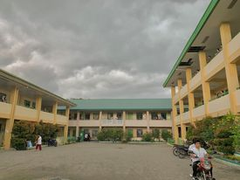

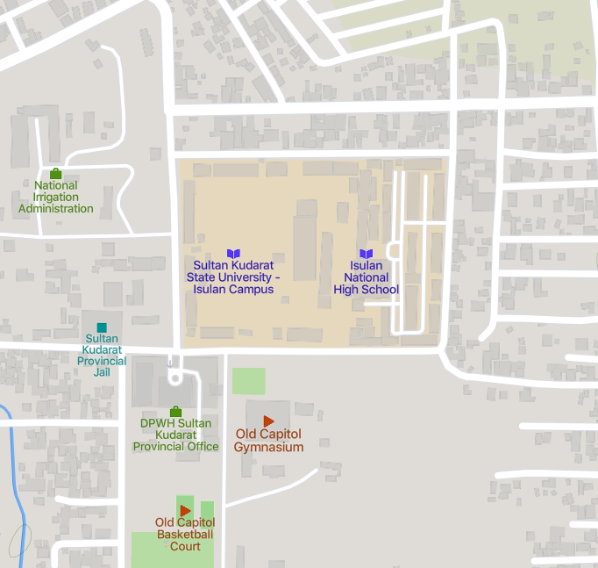

**Source**: googlemap.com

**Figure 1.** Map of Isulan National High School

**Participants**

The study’s participants are 9 teachers from Isulan National High School who are involved in action research. They are teachers with experience in conducting action research. These teachers provided descriptions of the barriers and challenges that they encounter in constructing action research.

**Sampling**

The participants will be purposively selected. They are the teachers in Isulan National High School that involved in making action research project. In qualitative research, purposive sampling is widely used to find and choose cases with plenty of relevant information on the phenomenon being studied (Palinkas et al., 2015).

**Instrument**

The semi-structured interview guide will be an essential mechanism for collecting descriptions of the teachers' hurdles and problems in doing action research. A semi-structured interview is a type of data gathering in which questions are posed within a preset theme framework. The instructors will be interviewed using semi-structured interview questions about their experiences, obstacles, and success stories from performing action research. The researcher will use McCracken's (1998) five-step qualitative interview approach to create a semi-structured interview guide in its final form. The problem statement will be used by the interviewer as the main question. The researcher will have the interview guide pilot tested for one week before the actual data gathering, after which related questions will be asked about the obstacles and difficulties teachers face while doing action research.

**Procedure**

The researchers will create a letter that will be signed by the Adviser and the Principal to get permission to perform the study.

After approval, the researchers will take the ethical principles in conducting this research. First, the researchers will make sure that the individuals provided their free and informed consent. Upon having such, it is predicted that they stand thoroughly notified of both its advantages and any present or future risk. Additionally, this stands consistently based on the ethical principle of freedom and their ability for decision-making. It also showed an understanding of the fact that the main goal of the study is to gather descriptions of participants’ experiences in constructing action research. Also, the teachers are free to decide whether they want to take part in the study or not. There will be instructions and further information proposed on how to engage completely in the study before they begin participation. Furthermore, by guaranteeing participants' secrecy and anonymity, it applied the principle of beneficence, doing good, and avoiding harm to use. The participants in this study are furnished “code names” to ensure privacy reporting, and after the data analysis is complete, they will remove their recorder interviews.

Next, the researcher will stick to the steps in creating a semi-structured interview by applying the 5-step qualitative interview process described by McCracken (1998). To document every piece of the discussion, audio will be recorded.

Following that, each interviewee’s response will be suitably transcribed, and the data will be carefully analyzed.

**Ethical Considerations**

To ensure the participants welfare, this study “Teachers’ Barriers and Challenges in Writing Action”, prioritized upholding ethical principles. The researcher observes the following considerations:

**Informed Consent,** prior to the start of the study, the researchers sought permission from the principal to conduct this study. The researchers informed all teachers' participants about the study's nature and purpose, the option of voluntary participation, and their right to withdraw from the study without any consequences. Additionally, the researchers have obtained information from all participants and explained the potential risks and benefits of participating in the study.

**Voluntary Participants**, the participation of students and teachers in the study was informed, and their decision to participate are not affected their academic or employment status. And there are no repercussions for declining to participate. Students and teachers who chose to participate were required to sign a consent form indicating their willingness to participate.

**Confidentiality and Privacy**, The researcher must guarantee that the participant's personal information and data are confidential and used solely for research purposes.

To protect the participants' identities, the researchers should exclude identifying information from the reports or published documents. The researcher must inform the participants that their information remains confidential, and that they have the right to access their data and request its deletion

**Data Analysis**

To determine the themes of the research study, the researchers employed Colaizzi's (1978) Thematic-Narrative Analysis to examine phenomenological data. To describe the dataset's analysis approach, brief descriptions of transcript production are used:

A thorough interview will be conducted utilizing the planned and established interview guide questions. An interview guide is a set of questions or themes that the interviewer wishes to cover throughout the duration of the interview. A vernacular translation of the interview guide questionnaire will be given for the benefit of the participants. The participants will speak in their own words about the barriers and challenges experienced in making action research. Each interview will be for a maximum of 15 to 20 minutes and the researcher will conduct this interview.

Meanwhile, Collaizzi’s method for thematic-narrative data analysis is represented by the following steps:

Every record will be read several times to get a general understanding of the entire text. For each transcript, key phrases that relate to the phenomenon under consideration will extract from the study. These statements must be written down on separate sheets noting the pages and lines they are on. From these important statements, meanings will be formulated. The specified meanings will be organized into groups, theme clusters, and developing topics. The study’s findings will be included in an in-depth description of the phenomenon under study. Finally, an overview of the phenomenon’s fundamental structure will be presented.

**CHAPTER IV**

**RESULTS AND DISCUSSION**

**Discussion**

The study explored the motivations, issues, barriers and challenges of teachers conducting action research from the narratives of the key informants. Several sub-themes surfaced from the Key Informant Interview that led to identifying the Themes.

**Research Question Number 1** inquired key informant's barriers and challenges in conducting action research. Barriers and challenges are situations that affects the engagement of teachers in conducting research activities. It is something that teachers are talking about, thinking about, and something that has a great impact on their undertakings. After a thorough analysis, three (3) themes emerged from this question. These include Time Factor, Support System, Expertise and Prior Experience Factor.

Hence, in this question, the following are the driving force of teachers engage in action research for further discussions:

**Theme 1: Time Factor**

With the strict implementation of DepEd Memorandum 291 s. 2008 and Magna Carta for Teachers on the observance of 6 teaching loads as nonnegotiable, teachers find it hard to find extra time to research because the time they had is consume by classes and activities whether it is inside or outside the school premises work loades can be complied by engaging in other teaching-related activities and duties including the conduct of research. Hence, some narratives can support this.

**Informant 1 (MT).** " The different barriers of teachers in Isulan National High School in making action research hmm are first, lack of time."

**Informant 2 (T-III).** "The main barriers I face as a teacher when writing action research we’re time. Those barriers such as time uhmm affected me to be able to cope or come up the good research study."

**Informant 3 (T-II).** " The first barrier for me is really time. Teachers do not have enough time hmm… due to our classroom responsibilities or preparation for our classes. "

**Informant 4 (T-I).** " Based on my experience, some of this barriers include uhm first one is the lack of time. teachers often have a busy schedule and which can make it challenging to find time when writing action research. . I also faced a lot of challenges of course the first one is time constrains."

The narrative from the informants emphasize the common difficulty that instructors have while undertaking action research: a lack of time. The limited time available for instructors to do research is a result of the stringent application of teaching loads and other duties. Additionally, Ulla et al. (2017) pointed out several issues, including insufficient research skills, heavy workload levels on teaching duties, and limited budgetary support that could hinder teachers' progress in implementing action research projects. As a result, professors struggle to find enough time to devote to their research projects, which hinders their capacity to carry out in-depth study that has value. It is essential to remove this obstacle and figure out how to provide instructors more time for research in order to encourage a research-oriented culture among educators and raise the standard of teaching. (Dissertation Revision 2017)

**Theme 2: Support System**

Regarding this theme, two points were established: funds and workloads. Informants clearly stated that in today's situation, conducting action research also involves monetary expenses that led them to waive or sacrifice their desire for action research instead of other expenses in school and at home. Meaning they viewed the conduct of action research as an additional expense since no budget had been allocated to teachers to conduct the said project. Looking at a clear view, they pointed out that in crafting the school improvement plan, a budget allocated for research was contained only in training and seminars and not for other expenses incurred during the conduct of the study in school. Some narratives could attest to this.

**Informant 1 (MT).** "...the lack of resources can cause a lack of interest."

**Informant 4 (T-I).** " So, third barrier for me is limited resources for support needed to conduct research.."

**Informant 5 (T-II).** "...tapos budget kay costly man talaga amon action research." (*Then, the budget because conducting action research can be costly when doing action research.)*

**Informant 9 (T-II).** "The main challenges as a teacher faced is lack of resources, this mean that the number of resources is small and sometimes these resources cannot be used. Lack of source majority of the resources need a lot of money which many of them find difficult to set."

Regarding support, as pointed out by workloads, some informants claimed that they considered conducting action research an challenge considering their workloads and other ancillary functions in school. With this, even if they want to conduct action research, they are bombarded with different teaching loads and functions, making them perceive action research as an additional burden. The narratives of the informants can support this.

**Informant 7 (T-II).** "...kung paano mo siya i-budget ang time mo kay syempre sa kwan hmm loaded ang imo subject at the same time pag weekend sa family naman, may trabaho ka man sa balay nyo kaya stressful sya." (*On how will you budget your time of course we are also loaded in your subject at the same time in the weekends in your family you also have work in your home its really stressful.)*

**Informant 4 (T-I).** "Teachers… we find it difficult to find the time to conduct action research particularly if we have a heavy teaching loads or other professional responsibilities. When conducting action research, this lack of support uhm can make it difficult to implement changes based on research findings."

**Informant 5 (T-II).** "so due to that madami kasing activity na ginagawa hindi siya masunod ang time." (*so due to that we have a large number of activities that we are doing we can’t follow the time.)*

**Informant 6 (T-II).** "...minsan napakaraming extra task na binibigay sa teacher kaya . Uhm, it will always fall down at saka sa financial." (*because sometimes there are so many extra task that is given to the teachers.)*

According to (Kutlay, 2012; Morales, 2016) the result teachers are overburdened with paper work, reports, and online duties in addition to face-to-face lessons as they try to bridge the gap experienced by the students as a result of the pandemic. Due to this, performing action research for teachers is seen as unnecessary baggage rather than something enjoyable and gratifying. (Mertler C. 2021)

**Theme 3: Expertise and Prior Experience Factor**

In this theme, informants highlighted that a lack of expertise and prior experience in conducting and writing action research posed a significant barrier, particularly for those with limited knowledge in the field. Difficulties developed in navigating the research process, framing questions, selecting procedures, collecting and evaluating data, and successfully conveying findings. Acquiring skill and experience was regarded critical for overcoming these challenges and obtaining meaningful outcomes in action research activities. Hence, some narratives can support this.

**Informant 2 (T-III).** " The particular challenges I face during the process of doing action research we’re lack of experiences in doing research."

**Informant 3 (T-II).** "Teachers some how specially not in line hindi namin linya yung research, hindi ano yun, hindi akma sa capacity namin yung research we are not willing to do it unless it is require pag nirequired ni school." (*Teachers, particularly those who are not in line with research, we find it difficult to conduct research that is not suitable for our capacity. We are not willing to do it unless it is required by the school, subject, or department as an action research.­)*

**Informant 4 (T-I).** "...the lack of research skills to design and conduct research study."

**Informant 7 (T-II).** "So, sa challenges is kung may ara sa part ko nga ga isip paano ko siya kay syempre limited lang ang knowledge ko sa action research so maka stress siya, hindi mo gid matapos kay limited lang ang knowledge kag idea mo." *(So, the challenge here is that I'm thinking about how to approach it because, of course, my knowledge in action research is limited, so it can be stressful. You can't really finish it because your knowledge and ideas are limited.)*

Most informants confirmed the above themes based on their willingness to do action research. Most needed more training, guidance, and opportunities to develop their research skills and gain experience in conducting action research. Consistently, Zhou (2012) also revealed that time and workloads are crucial issues in conducting action research. As a whole, they deemed research as a difficult undertaking. This supports the idea of Biruk (2015), highlighting that most teachers do not undertake action research due to constraints such as shortage of time, lack of research background, and lack of experience. Given that action research plays a significant role in improving teachers' practice in research activities and, at the same time, providing solutions they face in the teaching-learning process, teachers refrain from participating in action research because of the abovementioned problems. In addition, the narratives of the informants are consistent with the body of research, which indicates that instructors frequently ignore conducting action research due to time restrictions, resource limitations, a lack of research expertise, and other factors. In order to overcome these obstacles, instructors must be given more time, money, support, training, and direction to improve their research abilities and self-assurance. (Darling-Hammond 2017). In general, the results highlight the need of overcoming these obstacles to help teachers develop a research-oriented culture that will allow them to undertake action research successfully. By doing this, educators may improve their methods of instruction, solve difficulties in the classroom, and advance the teaching-learning process as a whole.

**Research Question Number 2** inquired the key informant's techniques to overcome the barriers and challenges in writing action research. Techniques to overcome the challenges in action research refer to specific strategies, methods, or approaches that researchers can employ to address and overcome the difficulties and obstacles they encounter during the process of writing action research. These techniques are designed to help researchers navigate the various challenges and enhance the effectiveness and success of their action research endeavors. After a thorough analysis, three (3) themes emerged from this question. These include solution to the problem, collaboration and support, and reflective practice and professional development. The underlying principles of these themes are discussed below.

**Theme 1: Solution to the Problem**

According to Manfra (2019), action research is an approach that emphasizes the active involvement of teachers in investigating and improving their own teaching practices. It is a reflective process that promotes continuous improvement and professional growth. After a thorough analysis the another theme develop is the solution to the problem. Informants shared the techniques that they use to overcome the barriers and challenges they experience when writing action research. The narratives below support this undertaking:

**Informant 1 (MT-I).**"Techniques that I applied to overcome the Barriers and challenges is Time management talaga. Us na teacher marami kaming responsibilities may mga task na naka assign to us and there would be many sacrifices. So, time management is really required and it helps me a lot to pursue different activities katulad nitong Action research." (*The different techniques that I applied to overcome the barriers and challenges is really time management. Us teachers that have many responsibilities there are many tasks that are assign to us and there would be many sacrifices. So, time management is really required and it helps me a lot to pursue different activities just like this action research.)*

**Informant 3 (T-II).** "Time management e aarange ko muna yung schedule ko then I will spend 1 hour after the class ahh itong time nato vacant ko I spend it doing action research formulating questionnaire formulating tools then uhhhmmm at the end of the day." (*Time management I will arrange first my schedule then I will spend 1 hour after class this time it`s my vacant I spend it on action research, formulating questionnaire, formulating tools then at the end of the day.)*

**Informant 4 (T-I).** " Based on my experience, some of this barriers include uhm first one is the lack of time. teachers often have a busy schedule and which can make it challenging to find time when writing action research. . I also faced a lot of challenges of course the first one is time constrains. Teachers… we find it difficult to find the time to conduct action research particularly if we have a heavy teaching loads or other professional responsibilities. So, third barrier for me is limited resources for support needed to conduct research. When conducting action research, this lack of support uhm can make it difficult to implement changes based on research findings. "

**Informant 5 (T-II).** " Okay. Siguro ano hmm time tapos budget kay costly man talaga amon action research. So due to that madami kasing activity na ginagawa hindi siya masunod. So, hmm most probably hindi masunod ang time ma-delay ang pag ano, pag conduct ng action research."( *Okay, I think the time. Then, the budget because conducting action research can be costly when doing action research. So due to that we have a large number of activities that we are doing we can’t follow the time that resulted a delay in conducting action research.)*

**Informant 6 (T-II).** "Shall we have, we are scheduling dapat meron siyang time management, tapos it would also be better kung ang admin or nasa office will give us the order ahead of the time para mas mahaba yung time nang month namin to conduct the action research*"(Shall we have, we are scheduling we nee to have time management, then it would also be better if the admin or the people on the office willgive us the order ahead of time so we can extend the time in a month to conduct our action research.)*

**Informant 8 (T-I).** "As a teacher, time management help me to overcome those barriers and challenges. Time management is essential in action research. By uhm setting specific timelines and hmm schedules help me to overcome those"

Another informant went on to say:

**Informant 7 (T-II).** "So the techniques I use to comprehend the action research is to have more knowledge about how to write action research,"

The data show that instructors face numerous kinds of challenges and difficulties while producing action research reports. Teachers commonly cited difficulty writing and doing research, as well as a lack of time, in the study conducted by Bullo et al. (2021). Maravilla's (2020) study provides more data in support of these conclusions. However, According to Darling Hammond (2019) numerous strategies have come up with answers to these constraints as a result of the informants' narratives. Time management was identified as a critical method, allowing instructors to arrange specific time for action research in the middle of their hectic schedules. Appropriate planning, scheduling, and prioritizing were stressed. Seeking assistance from school administration and having access to essential resources were also indicated as critical elements in promoting action research. Acquiring information and comprehending the process of writing action research were also cited as beneficial strategies. Finally, good time management, stakeholder support, and collecting relevant information are critical approaches that assist instructors in overcoming hurdles and problems when doing action research.

**Theme 2: Collaboration and Support**

Collaboration and support among teachers play a crucial role in fostering professional growth and improving educational practices. When it comes to action research, which involves conducting systematic investigations to address specific issues in the classroom, collaboration and support become even more important (Garces,2016). However, there are various barriers and challenges that teachers may encounter when engaging in the process of writing action research reports.

**Informant 2 (T-III).** "I maybe not good in research, in doing action research but as a teacher I need to do so, I need some study, lots of readings and practice to help me face those challenges and barriers. Learning is a process. I maybe not that good or cannot work with my best action research alone because here we are doing it as group right."

**Informant 7 (T- II).** "I will probably do is to find someone That is a expert in writing action research, I will ask for ideas, knowledge so I can use it when doing action research."

**Informant 9 (T-II).**" I also collaborate with others, and uhm hmm like I seek support and also reflecting on the process.”

Subsequently in the framework of action research, collaboration and support among instructors are vital. Teachers recognize the difficulties they encounter and the need of ongoing learning and seeking help. Collaborating with peers allows for information sharing and assistance, as well as developing research abilities and instructional techniques. According to Erba (2013) in order for teachers to actively participate in making action research, they must possess negotiation abilities, teamwork, opportunity, and reactivity. Additionally, creating a collaborative and supportive atmosphere is critical for the effective implementation of action research and the promotion of meaningful and impactful outcomes.

**Theme 3: Reflective Practice and Professional Development**

Effective teaching involves reflective practice and professional development. Teachers participate in a cyclical and systematic process of examining, analyzing, and evaluating their teaching experiences through reflective practice. This allows them to obtain useful information, improve their educational strategies, and address their students' different requirements. Professional development supplements reflective practice by allowing instructors to gain new information, skills, and techniques to improve their teaching practices. Teachers may continuously evolve, adapt to changing educational environments, and provide meaningful learning experiences for their students by integrating reflective practice and continuing professional development.

**Informant 4 (T-I)** " it will benefits a lot specially to the teachers who are doing the action research, it helps teachers to become more reflective practitioner through reflection teacher can learned huge strategy for improving student outcomes, and it helps teacher developed a short understanding of teaching and learning this can lead show collaboration among educators in improved communication between teacher and students.”

**Informant 6 (T-II).** " Among the benefits would be, we will be able to address the barriers of learners in learning the competencies wherein they think are, where they find it difficult to understand."

**Informant 8 (T-I).** "Action research can contribute to the body of knowledge and allow us to learn with our actions of course it allows us to adapt the teaching practices that are beneficial to students. "

By engaging in reflective inquiry, teachers can enhance their teaching strategies, address student barriers, and foster collaboration among educators. Additionally, Mertler (2021) stated that this leads to greater communication between instructors and students, improved student results, and the development of a deeper knowledge of teaching and learning. Furthermore, action research adds to the corpus of knowledge and allows instructors to change their activities to benefit pupils. Overall, reflective practice and professional growth are critical for supporting successful teaching and meaningful learning experiences. (Farrell, 2016).

**CHAPTER V**

**CONCLUSIONS AND RECOMMENDATIONS**

This chapter presents the conclusions and recommendations obtained from the study.

**Conclusions**

Action research gives teachers a practical application in addressing challenges they encounter in the performance of their duty as teachers. Different themes emerged during the thorough analysis of the textual data. The key informants see action research engagement as personal and professional development, given that research gives solutions to problems encountered inside the classroom, improves the teaching and learning process, and, eventually, a factor in promotion. However, the informants' confidence in conducting action research subsides because they have writing difficulties. Thus, time factor and support system become the top issue in conducting action research considering the lack of time, provision of funds and their workloads in school. Furthermore, they deemed research difficult because they are not knowledgeable enough about writing action research. Hence, they need professional help. In conclusion, it is essential to support teachers in overcoming the barriers and challenges they face in conducting action research, as this can lead to improved teaching practices and a more effective educational system.

**Recommendations**

On the premise of the results of the study, the following recommendations are made:

1. School Heads and Administrators should extend their support to teachers by sending them to research seminars, training, workshops, and other activities designed for them to be more prepared in conducting research and develop a growth mindset of time-management, prioritization, and professional development.
2. The Department of Education should implement a flexible teaching load policy that acknowledges the significance of research activities. This policy would enable teachers to allocate dedicated time for writing action research. The head of each school is advised to support research projects that particularly address the topics that emerged from this study.
3. A seminar workshop on Action Research making will be conducted and spearheaded by the School Research Coordinator that will focus on the difficulties encountered by the key informants of this study.
4. Establish mentoring programs to provide guidance and support for teachers engaging in action research.
5. Provide financial assistance or grants specifically designated for action research projects.

6. It is also advised that a similar study be carried out in a larger area.

**References**

**Abaya, E. (2017)**. Situating action research in the institutionalization of culture of research and teacher agency. Presented during the National Conference on Research in Teacher Education. University of the Philippines. <http://www.uoh.edu.pk/hjer/view-article.php?file=p224a4q5e4w5l2t4m4j4y3v2t2e4y5k4n4c4r25424q2w2p20314h464j5>

**Albalawi, A. (2022).** Action Research Among Public School Teachers. https://eric.ed.gov/?id=EJ1346963

**Ambag, S. (2015).** Assessment of Competency Level of Pre-Service Teachers Based on National Competency- Based Teacher Standards (NCBTS) in Public School in the National Capitol Region (NCR). <https://euacademic.org/uploadarticle/1333.pdf>

**Basic Education Research Agenda of (2016).** http://danrogayan.weebly.com/uploads/8/2/7/4/82740308/basic_education_research_agenda.pdf

**Barrera, A. (2017).** Social Economy and Critical Thinking. Apontes for the Analysis of the Current Scenario.https://www.scirp.org/(S(i43dyn45teexjx455qlt3d2q))

**Beauchamp, C., & Thomas, L. (2009).** Understanding teacher identity: An overview of issues in the literature and implications for teacher education. Cambridge Journal of Education, <https://doi.org/10.1080/03057640902902252>**]**

**Bocar, A. C. (2013).** Difficulties Encountered by the Student Researchers and the Effects on Their Research Output. SSRN Electronic Journal, 1-7.https://www.researchgate.net/publication/255967042

**Bullo, Labastida, and Manalapan (2021).** Challenges and difficulties encountered by teachers in the conduct of educational research: Basis for teachers’ enhancement program. <https://www.researchgate.net/publication/353803414_Challenges_and_difficulties_encountered_by_teachers_in_the_conduct_of_educational_research_Basis_for_teachers’_enhancement_program>

**Burns, M. (2019).** Distance Education for Teacher Training: Modes, Model, and Methods. [https://www.edc.org/sites/default/files/uploads/Distance-Education-Teacher Training.pdf?fbclid=IwAR3Koxd4pHlpv6AZPtl2FGu1V2hWuhSCWRP7IPd1nmw0pBjvl9IOhYoN-w0](https://www.edc.org/sites/default/files/uploads/Distance-Education-Teacher%20Training.pdf?fbclid=IwAR3Koxd4pHlpv6AZPtl2FGu1V2hWuhSCWRP7IPd1nmw0pBjvl9IOhYoN-w0)

**Burns, A., & Kurtoglu-Hooton, N. (2014).** Implementing action research in the modern language classroom. <https://www.scilt.org.uk/Portals/24/Library/slr/issues/27/27-3%20Burns_Kurtoglu-Hooton.pd>

**Campbell, K. H. (2011).** Teacher as researcher: An essential component of teacher preparation. Northwest Passage, 9(2), 23–34. <https://journals.researchsynergypress.com/index.php/ijtaese/article/download/1020/534>

**Chou, C. H. (2011).** Teachers’ Professional Development: Investigating Teachers’ Learning to Do Action Research in a Professional Learning Community. Asia-Pacific Education Researcher (De La Salle University Manila) <https://www.researchgate.net/publication/285944593_Teachers’_Professional_Development_Investigating_Teachers’_Learning_to_Do_Action_Research_in_a_Professional_Learning_Community>

**Clarke, L., & Embury, D. (2016).**Turning Teachers into Action Researchers in their Classrooms. Kentucky Teacher Education Journal: Journal of the Teacher Education Division of the Kentucky Council for Exceptional Children. Eastern Kentucky University. <http://digitalcommons.wku.edu>

**Colaizzi, P. (1978).** Psychological research as a phenomenologist views it. https://eprints.hud.ac.uk/id/eprint/26984/1/

**Creswell, JW (2007).** Five qualitative approach to inquiry. <https://www.ncbi.nlm.nih.gov/pmc/articles/PMC6468135/>

**Cunningham, D. (2011).** Improving Teaching with Collaborative Action Research: An ASCD Action Tool. Alexandria, VA: ASCD. <https://eric.ed.gov/?id=ED516354>

**Darling-Hammond, L. (2017).** Effective teacher professional development. Palo Alto, CA: Learning Policy Institute. https://learningpolicyinstitute.org/sites/default/files/product-files/Effective_Teacher_Professional_Development_REPORT.pdf

**De Borja, M. A. (2018).** Teacher Action Research its Difficulties and Implications. https://www.researchgate.net/publication/323747753

**Demin, J. (2013).** Proposed Agenda based on Foregoing BSED Social Studies Major [Unpublished Thesis]. College of Teacher Education. Southern Luzon State. <http://www.globalscientificjournal.com/researchpaper/ACTION_RESEARCH_ENGAGEMENT_OF_THE_TEACHERS_IN_DO_A_SUSANA_MADRIGAL_ELEMENTARY_SCHOOL_BASIS_FOR_ACTION_PLAN.pdf>

**Dehghan and Sahragard (2015)**. A narrative study of Iranian EFL teachers' experiences of doing action research https://www.researchgate.net/publication/312016893_A

**Department of Education (2016**). Filipino teachers’ experiences as curriculum policy implementers in the evolving K to 12.https://search.informit.org/doi/abs/10.3316/informit.085730319385430

**Department of Education (2017).** Action research. Retrieved from google/15dTsf

**Dissertation Revision (2017).** Top 10 Challenges Faced By Researchers In Developing Countries. https://www.dissertationrevision.com/top-10-challenges-faced-by-researchers-in-developing-countries/

**Erba, B. (2013).**The Practice and Challenges in Conducting Action Research: The case of Sululta Secondary School [Unpublished thesis]. Addis Ababa University Addis Ababa, Ethiopia. <https://journals.researchsynergypress.com/index.php/ijtaese/article/download/1020/534>

**Farrell, T. (2016a).** TESOL, a profession that eats its young! The Importance of reflective practice in language teacher education. Iranian Journal of Language Teaching Research, <https://files.eric.ed.gov/fulltext/EJ1127348.pdf>

**Finlay, L. (2008).** Reflecting on reflective practice. Practice-based Professional Learning Paper 52, 1–26. The Open University.<http://oro.open.ac.uk/68945/1/Finlay-%282008%29-Reflecting-on-reflective-practice-PBPL-paper-52.pdf>

**Garces, A.Y.C. and Granada, L. (2016).** The role of collaborative action research in teachers’ professional development. 18 (1). <http://dx.doi.org/10.15446/profile.v18n1.49148>

**Hazelton, J., & Haigh, M. (2010)**. Incorporating sustainability into accounting curricula: lessons learnt from an action research study. Accounting Education: an international journal, 19(1-2), 159-178. <https://www.researchgate.net/publication/4>

**Kemmis, S., &McTaggart, R. (Eds.) (1988).** The action research planner. Victoria, Australia: Deakin University. <http://elibrary.mukuba.edu.zm:8080/jspui/bitstream/123456789/625/1/The%20Action%20Research%20Planner.pdf>

**Koellner, K., & Jacobs, J. (2015).** Distinguishing models of Professional development: The case of an adaptive model’s impact on teachers’ knowledge, instruction, and student achievement. Journal of Teacher Education, <https://doi.org/10.1177/0022487114549599>

**Kutlay, N. (2012).** A survey of English language teachers’ views of research. Procedia – Social and Behavioral Sciences. 70, 188-206 <https://doi.org/10.1016/j.sbspro.2013.01.055>

**Licklider, B. L. (1997).** Action Research as Professional Development: A Study of Two Teachers. https://scholarsarchive.byu.edu/cgi/viewcontent.cgi?article=2626&context=etd

**Lingard et al. (2008).** Managing Change in Healthcare: Using Action Research.https://www.bing.com/ck/a?!&&p=fae5880142f98983JmltdHM9MTY4NDk3MjgwMCZpZ3VpZD0xZjcwZjdmZC1iYWZmLTZhZTYtMzJlMi1lNzFlYmI5YTZiNDMmaW5zaWQ9NTIwOQ&ptn=3&hsh=3&fclid=1f70f7fd-baff-6ae6-32e2-e71ebb9a6b43&psq=s+(Lingard+et+al.%2c+2008%3b+%0d%0aWhitehead+et+al.%2c+2003).&u=a1aHR0cHM6Ly93d3cucmVzZWFyY2hnYXRlLm5ldC9wdWJsaWNhdGlvbi8yOTI2NTQwOTFfTWFuYWdpbmdfY2hhbmdlX2luX2hlYWx0aGNhcmVfVXNpbmdfYWN0aW9uX3Jlc2VhcmNo&ntb=1

**Manongsong, M. J. G. & Panopia, E. (2018).** Dentistry faculty members’ research competencies and attitude towards research engagement. Asia Pacific Journal of Education, Arts and Sciences. <http://apjeas.apjmr.com/wp-content/uploads/2018/10/APJEAS-2018.5.3.02.pdf>

**Maravilla, M. A. 2020.** Teachers’ attitudes towards research at Palawan State University–Puerto Princesa. <https://scholar.google.com/citations?view_op=view_citation&hl=en&user=xUgaBTsAAAAJ&citation_for_view=xUgaBTsAAAAJ:qjMakFHDy7sC>

**Marzo, C.C. (2017).** Level of competence in conducting action research of elementary school teachers in the Second Congressional District of Quezon: Basis for an enhancement. <https://ojs.aaresearchindex.com/index.php/AAJMRA/article/view/8153>

**Mathew, P., & Peechattu, P. (2017**) Reflective practices: A means to Teacher development. Asia Pacific Journal of Contemporary Education and Communication Technology, 126–131.https://apiar.org.au/wp-content/uploads/2017/02/13_APJCECT_Feb_BRR798_EDU-12

**McCracken, G. D. (1998).** The long interview.<https://www.researchgate.net/publication/227430203_The_qualitative_research_interview>

**McGee, A. (2008).** Critical reflections of action research used for professionaldevelopment in a MiddleEastern Gulf State, Educational Action Research. <https://eric.ed.gov/?id=EJ811234>

**Mertler, A. C. (2021).** Action research as teacher inquiry: A Viable Strategy for Resolving Problems of Practice. https://scholarworks.umass.edu/pare/vol26/iss1/19/

**Mertler, C., & Hartley, A. (2017).** Classroom-based, teacher-led action research as a process for enhancing teaching and learning. Journal of Educational Leadership in Action, 4(2). Retrieved September 30, 2019, from <https://www.lindenwood.edu/academics/beyond-the-classroom/publications/journal-of-educationalleadership-in-action/all-issues/previous-issues/volume-4-issue-2/faculty-articles/mertler/>

**Morales, M., Abulon, E., Soriano, P., David, A., Hermosisima, V., & Gerundio, M. (2016).** Examining teachers’ conceptions of and needs on action research. Issues in Educational Research, 26(3), 464-489. <https://www.iier.org.au/iier26/morales-2.pdf>Nagibova, 2019

**Norasmah and Chia (2016).**Problems Teachers Face When Doing Action Research and Finding Possible Solutions. <https://www.researchgate.net/publication/275838650_Problems_Teachers_Face_When_Doing_Action_Research_and_Finding_Possible_Solutions>

**Palinkas, L.A., et al. (2015).** Purposeful Sampling for Qualitative Data Collection and Analysis in Mixed Method Implementation Research. https://www.ncbi.nlm.nih.gov/pmc/articles/PMC4012002/

**Oestar, J.M (2022).** Conveying communicative intent: Rhetoric moves and metadiscourse in DepEd founded papers. [Dissertation]. Manuel S. EnvergaUniversity Foundation. <https://www.researchgate.net/publication/366896383_Decoding_Communicative_Intent_Rhetoric_Moves_and_Metadiscourse_in_DepEd_Funded_Research_Papers>

**Regional Memorandum No. 144 s. (2015).** https://www.deped.gov.ph/wp-content/uploads/2015/11/DM_s2015_144.pdf

**The Glossary of Education Reform (2021).** Public, online resource that defines and describes major terms, concepts, and strategies in public-education.reform.https://www.newenglandssc.org/resources/glossary-of-education

**Tindowen, D. J. C., & Cagurangan, J. A. (2017).**Twenty-First-Century Skills of Alternative Learning System Learners, <https://journals.sagepub.com/doi/abs/10.1177/2158244017726116>

**Tindowen, D. J. C. (2019).** Researchers’ Perspective in Conducting Action Research. http://www.vnseameo.org/InternationalConference2022/wp-content/uploads/2022/07/Researchers_-Perspective-in-Conducting-Action-Research-SEAMEO.pdf

**Ulla, M. B., Barrera, K. B., & Acompanado, M. M. (2017**). Philippine Classroom Teachers as Researchers: Teachers’ Perceptions, Motivations, and Challenges. Australian Journal of Teacher Education, 42(11).<http://dx.doi.org/10.14221/ajte.2017v42n11.4>

**Zhou, J. (2012).** Problems teachers face when doing action research and finding possible solutions, Chinese Education and Society, 45(4), 68-80. https://www.researchgate.net/publication/275838650_Problems_Teachers_Face_When_Doing_Action_Research_and_Finding_Possible_Solutions

**APPENDICES**

**APPENDIX A**

**Semi-Structured Interview Questionnaire**



Republic of the Philippines

Region XII

Division of Sultan Kudarat

**Isulan National High School**

Kalawag II, Isulan, Sultan Kudarat

School Year 2022-2023

**TEACHERS’ BARRIERS AND CHALLENGES IN WRITING ACTION RESEARCH**

Semi-Structured Interview Questions

1. What are the barriers and challenges faced by Isulan National High School Teacher in writing action research?
   1. What are the main barriers you faced as a teacher when writing action research?
   2. What particular challenges did you faced during the process of doing action research?
   3. How do the barriers and challenges affect your ability to effectively engage in action research?
2. How do teachers overcome the barriers and challenges of implementing action research in their teaching practice?

2.1. What are the techniques you apply to overcome the barriers and challenges you faced?

2.2. What are the benefits of overcoming these challenges and successfully implementing action research in your teaching practice?

Prepared by:

**Princess Gwen Nacin**

**Jonalyn Manalo**

Student-Researchers

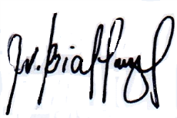

Noted:

**VINCENT B. BIALEN, MAT**

Adviser

**APPENDIX B**

**Letter of Request to the Principal for the**

**Conduct of the Study**



Republic of the Philippines

**Department of Education**

Region XII

Divission of Sultan Kudarat

Isulan National High School

Kalawag II, Isulan, Sultan Kudarat

June 13, 2023

**LORELY ANNE F. VALENCIA, ED. D.**

Principal II

Isulan National High School

Kalawag II, Isulan, Sultan Kudarat

Ma’am:

Greetings of Peace and Prosperity!

We are **Princess Gwen Nacin** and **Jonalyn Manalo**, the team leaders of Grade 11 HUMSS 3 are presently working a study entitled **“TEACHERS’ BARRIERS AND CHALLENGES IN WRITING ACTION RESEARCH”** in partial fulfillment of the requirement in Practical Research I.

In this connection, may we request from your good office to allow us to conduct our study in our school, with the Junior and Senior High School Teachers who has experience in writing action research as participants of the study. Rest assured that the information and data gathered would be treated with confidentiality.

Your kind assistance and approval of this endeavor will contribute to the realization of our study and will be remembered always.

Respectfully yours,

**PRINCESS GWEN NACIN**

**JONALYN MANALO**

Team Leaders

Noted:

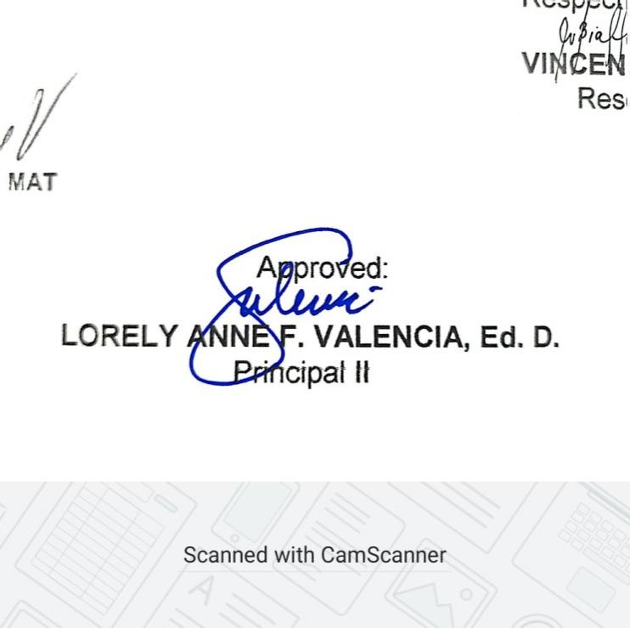**VINCENT B. BIALEN**

Research Adviser

**APPENDIX C**

**Informed Consent**



Republic of the Philippines

Region XII

Division of Sultan Kudarat

**Isulan National High School**

Kalawag II, Isulan, Sultan Kudarat

School Year 2022-2023

**Informed Consent**

We are from **Grade 11 HUMSS 3** of Isulan National High School, Isulan, Sultan Kudarat. We invite you to participate in the study “**TEACHERS’ BARRIERS AND CHALLENGES IN WRITING ACTION RESEARCH**”. The goal of this study is to better understand the barriers and challenges faced by the teachers of Isulan National High School in writing action research. By participating in this study, you will be helping us to understand the challenges and experiences of teachers when writing action research.

This study consists of doing a single interview.  The interview you will do with us shall take place in a private location of your choice and shall last approximately thirty minutes.  In the interview, we shall ask for your challenges and experiences when writing action research. Your ideas shall help us identify and refine themes to be explored later in interviews.

Participation in this study is completely voluntary; it is entirely up to you to choose to participate or not to participate.  You can choose to leave this study at any time.  Nothing will happen if you decide to stop.

With your permission, we would like to audio record the interview.  The audio recordings will be used in writing up the interview, to help make sure the write-up is accurate and complete.  Only members of the research team shall have access to the recordings.  The recording will be erased from the recorder as soon as it is transferred onto the computer.  The computer files of the audio-recordings will be password protected during the study and deleted at the end of the study.  Refusing the recording does not mean you cannot participate in the study.

The risks of participating in this study are minimal.  It is possible that you might get tired during the interview.  You may find some of the questions uncomfortable or hard to answer.  If this happens, we can discuss the situation, take a break, or stop.  If you choose to stop, we can either finish the interview another day or you can end your participation in the study.

This research is intended to help us understand the barriers and challenges faced by teachers when writing action research. The alternative to participating in the study is not to participate. There shall be no compensation for your participation in this study. Your privacy is protected as a participant in this study.  There will be a number rather than your name on copies of your interview.  None of the information you give us will be shared with anyone outside the research project.  Your name will not be used in any written reports or published articles that result from this project.

Though unlikely, there is always a chance of breach of confidentiality when taking part in a research study.  We shall make every effort to protect you from this risk.  Every effort will be made to ensure that descriptions of you as an individual in reports or articles are done in ways that mask your identity.

Your participation in this study is voluntary and you have the right to refuse to participate.  If you change your mind about participating at any time, including during the interview, you have the right to withdraw.

If you have questions about this research, you may contact Princess Gwen E. Nacin, the Team Leader on mobile number:  09677108412 or you may visit them at their classroom.

I have fully explained to the participant the nature and purpose of the procedures described above and the risks involved in participating in this study.  I have asked if any questions have arisen regarding the procedures and I have answered these questions to the best of my ability.

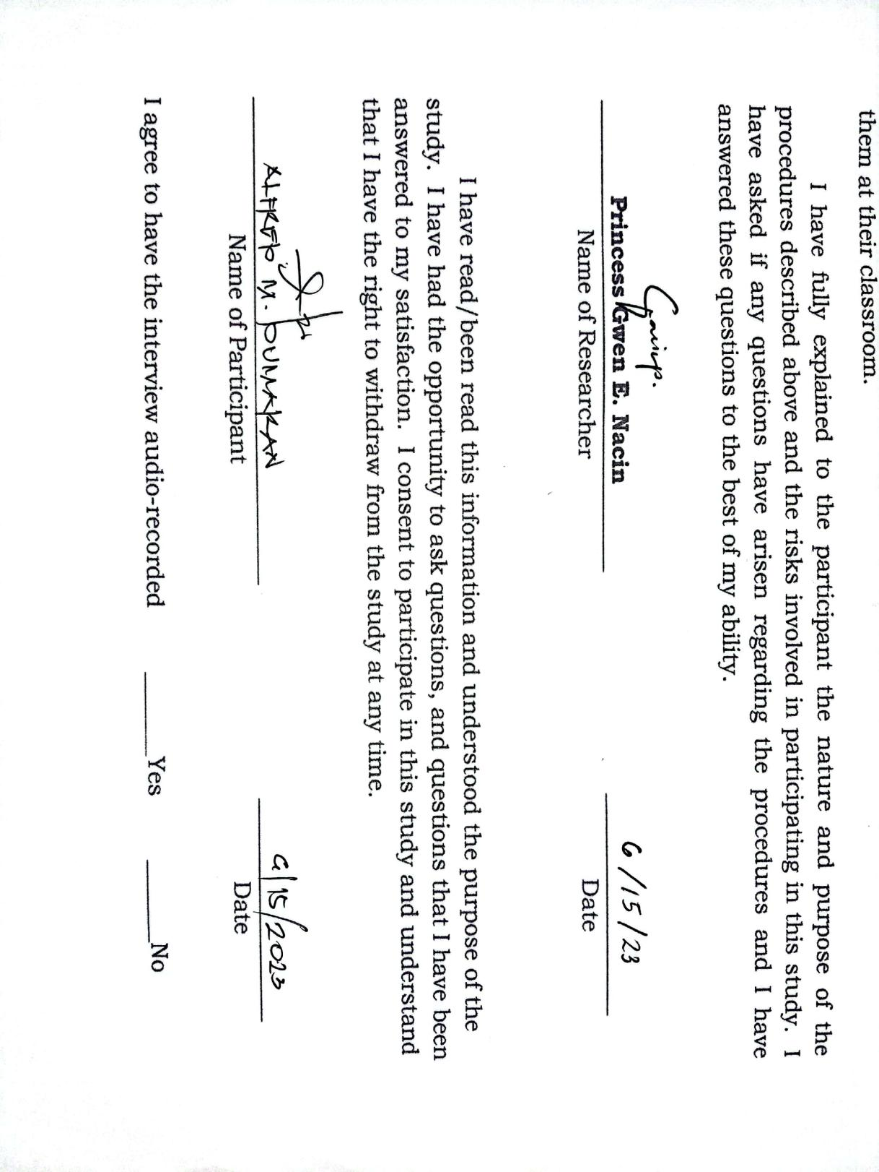

Republic of the Philippines

Region XII

Division of Sultan Kudarat

**Isulan National High School**

Kalawag II, Isulan, Sultan Kudarat

School Year 2022-2023

**Informed Consent**

We are from **Grade 11 HUMSS 3** of Isulan National High School, Isulan, Sultan Kudarat. We invite you to participate in the study “**TEACHERS’ BARRIERS AND CHALLENGES IN WRITING ACTION RESEARCH**”. The goal of this study is to better understand the barriers and challenges faced by the teachers of Isulan National High School in writing action research. By participating in this study, you will be helping us to understand the challenges and experiences of teachers when writing action research.

This study consists of doing a single interview.  The interview you will do with us shall take place in a private location of your choice and shall last approximately thirty minutes.  In the interview, we shall ask for your challenges and experiences when writing action research. Your ideas shall help us identify and refine themes to be explored later in interviews.

Participation in this study is completely voluntary; it is entirely up to you to choose to participate or not to participate.  You can choose to leave this study at any time.  Nothing will happen if you decide to stop.

With your permission, we would like to audio record the interview.  The audio recordings will be used in writing up the interview, to help make sure the write-up is accurate and complete.  Only members of the research team shall have access to the recordings.  The recording will be erased from the recorder as soon as it is transferred onto the computer.  The computer files of the audio-recordings will be password protected during the study and deleted at the end of the study.  Refusing the recording does not mean you cannot participate in the study.

The risks of participating in this study are minimal.  It is possible that you might get tired during the interview.  You may find some of the questions uncomfortable or hard to answer.  If this happens, we can discuss the situation, take a break, or stop.  If you choose to stop, we can either finish the interview another day or you can end your participation in the study.

This research is intended to help us understand the barriers and challenges faced by teachers when writing action research. The alternative to participating in the study is not to participate. There shall be no compensation for your participation in this study. Your privacy is protected as a participant in this study.  There will be a number rather than your name on copies of your interview.  None of the information you give us will be shared with anyone outside the research project.  Your name will not be used in any written reports or published articles that result from this project.

Though unlikely, there is always a chance of breach of confidentiality when taking part in a research study.  We shall make every effort to protect you from this risk.  Every effort will be made to ensure that descriptions of you as an individual in reports or articles are done in ways that mask your identity.

Your participation in this study is voluntary and you have the right to refuse to participate.  If you change your mind about participating at any time, including during the interview, you have the right to withdraw.

If you have questions about this research, you may contact Princess Gwen E. Nacin, the Team Leader on mobile number:  09677108412 or you may visit them at their classroom.

I have fully explained to the participant the nature and purpose of the procedures described above and the risks involved in participating in this study.  I have asked if any questions have arisen regarding the procedures and I have answered these questions to the best of my ability.

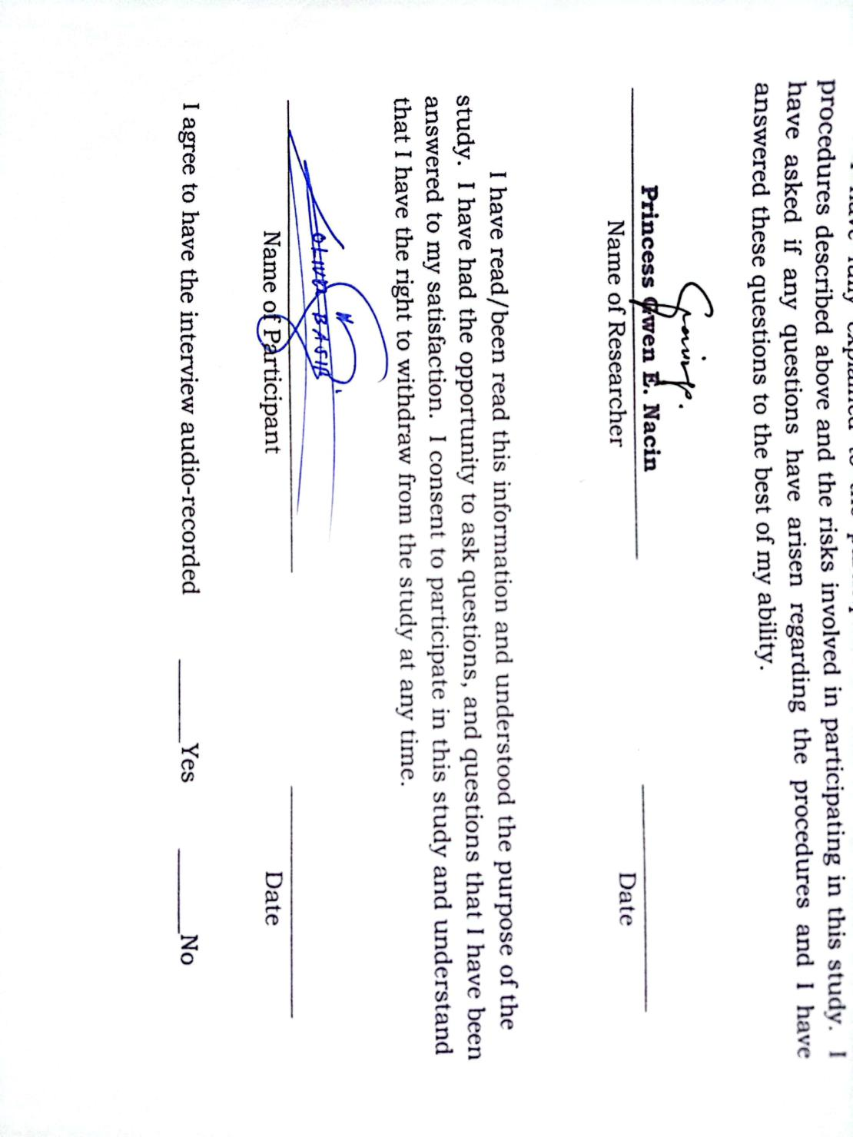

Republic of the Philippines

Region XII

Division of Sultan Kudarat

**Isulan National High School**

Kalawag II, Isulan, Sultan Kudarat

School Year 2022-2023

**Informed Consent**

We are from **Grade 11 HUMSS 3** of Isulan National High School, Isulan, Sultan Kudarat. We invite you to participate in the study “**TEACHERS’ BARRIERS AND CHALLENGES IN WRITING ACTION RESEARCH**”. The goal of this study is to better understand the barriers and challenges faced by the teachers of Isulan National High School in writing action research. By participating in this study, you will be helping us to understand the challenges and experiences of teachers when writing action research.

This study consists of doing a single interview.  The interview you will do with us shall take place in a private location of your choice and shall last approximately thirty minutes.  In the interview, we shall ask for your challenges and experiences when writing action research. Your ideas shall help us identify and refine themes to be explored later in interviews.

Participation in this study is completely voluntary; it is entirely up to you to choose to participate or not to participate.  You can choose to leave this study at any time.  Nothing will happen if you decide to stop.

With your permission, we would like to audio record the interview.  The audio recordings will be used in writing up the interview, to help make sure the write-up is accurate and complete.  Only members of the research team shall have access to the recordings.  The recording will be erased from the recorder as soon as it is transferred onto the computer.  The computer files of the audio-recordings will be password protected during the study and deleted at the end of the study.  Refusing the recording does not mean you cannot participate in the study.

The risks of participating in this study are minimal.  It is possible that you might get tired during the interview.  You may find some of the questions uncomfortable or hard to answer.  If this happens, we can discuss the situation, take a break, or stop.  If you choose to stop, we can either finish the interview another day or you can end your participation in the study.

This research is intended to help us understand the barriers and challenges faced by teachers when writing action research. The alternative to participating in the study is not to participate. There shall be no compensation for your participation in this study. Your privacy is protected as a participant in this study.  There will be a number rather than your name on copies of your interview.  None of the information you give us will be shared with anyone outside the research project.  Your name will not be used in any written reports or published articles that result from this project.

Though unlikely, there is always a chance of breach of confidentiality when taking part in a research study.  We shall make every effort to protect you from this risk.  Every effort will be made to ensure that descriptions of you as an individual in reports or articles are done in ways that mask your identity.

Your participation in this study is voluntary and you have the right to refuse to participate.  If you change your mind about participating at any time, including during the interview, you have the right to withdraw.

If you have questions about this research, you may contact Princess Gwen E. Nacin, the Team Leader on mobile number:  09677108412 or you may visit them at their classroom.

I have fully explained to the participant the nature and purpose of the procedures described above and the risks involved in participating in this study.  I have asked if any questions have arisen regarding the procedures and I have answered these questions to the best of my ability.

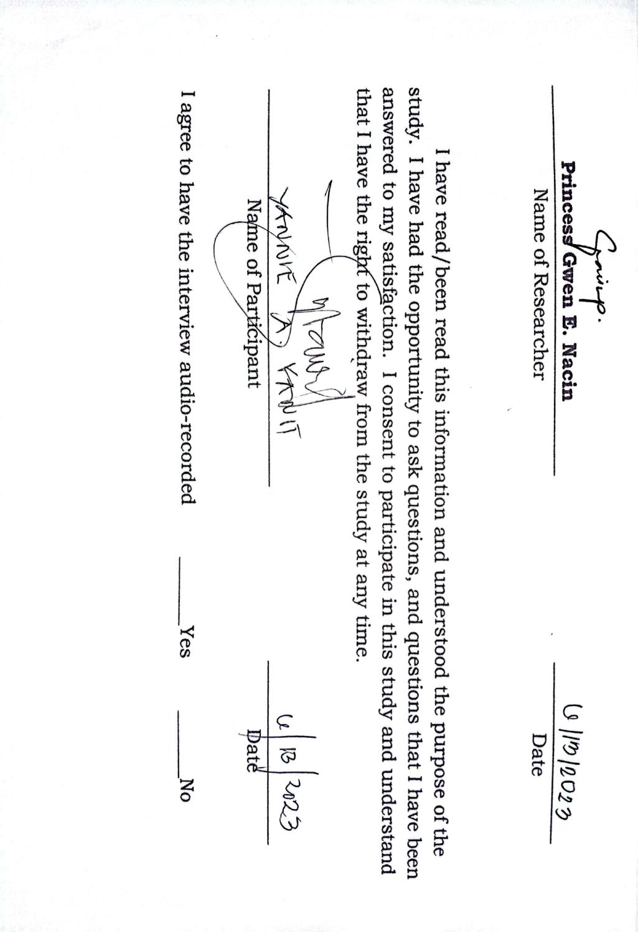

Republic of the Philippines

Region XII

Division of Sultan Kudarat

**Isulan National High School**

Kalawag II, Isulan, Sultan Kudarat

School Year 2022-2023

**Informed Consent**

We are from **Grade 11 HUMSS 3** of Isulan National High School, Isulan, Sultan Kudarat. We invite you to participate in the study “**TEACHERS’ BARRIERS AND CHALLENGES IN WRITING ACTION RESEARCH**”. The goal of this study is to better understand the barriers and challenges faced by the teachers of Isulan National High School in writing action research. By participating in this study, you will be helping us to understand the challenges and experiences of teachers when writing action research.

This study consists of doing a single interview.  The interview you will do with us shall take place in a private location of your choice and shall last approximately thirty minutes.  In the interview, we shall ask for your challenges and experiences when writing action research. Your ideas shall help us identify and refine themes to be explored later in interviews.

Participation in this study is completely voluntary; it is entirely up to you to choose to participate or not to participate.  You can choose to leave this study at any time.  Nothing will happen if you decide to stop.

With your permission, we would like to audio record the interview.  The audio recordings will be used in writing up the interview, to help make sure the write-up is accurate and complete.  Only members of the research team shall have access to the recordings.  The recording will be erased from the recorder as soon as it is transferred onto the computer.  The computer files of the audio-recordings will be password protected during the study and deleted at the end of the study.  Refusing the recording does not mean you cannot participate in the study.

The risks of participating in this study are minimal.  It is possible that you might get tired during the interview.  You may find some of the questions uncomfortable or hard to answer.  If this happens, we can discuss the situation, take a break, or stop.  If you choose to stop, we can either finish the interview another day or you can end your participation in the study.

This research is intended to help us understand the barriers and challenges faced by teachers when writing action research. The alternative to participating in the study is not to participate. There shall be no compensation for your participation in this study. Your privacy is protected as a participant in this study.  There will be a number rather than your name on copies of your interview.  None of the information you give us will be shared with anyone outside the research project.  Your name will not be used in any written reports or published articles that result from this project.

Though unlikely, there is always a chance of breach of confidentiality when taking part in a research study.  We shall make every effort to protect you from this risk.  Every effort will be made to ensure that descriptions of you as an individual in reports or articles are done in ways that mask your identity.

Your participation in this study is voluntary and you have the right to refuse to participate.  If you change your mind about participating at any time, including during the interview, you have the right to withdraw.

If you have questions about this research, you may contact Princess Gwen E. Nacin, the Team Leader on mobile number:  09677108412 or you may visit them at their classroom.

I have fully explained to the participant the nature and purpose of the procedures described above and the risks involved in participating in this study.  I have asked if any questions have arisen regarding the procedures and I have answered these questions to the best of my ability.

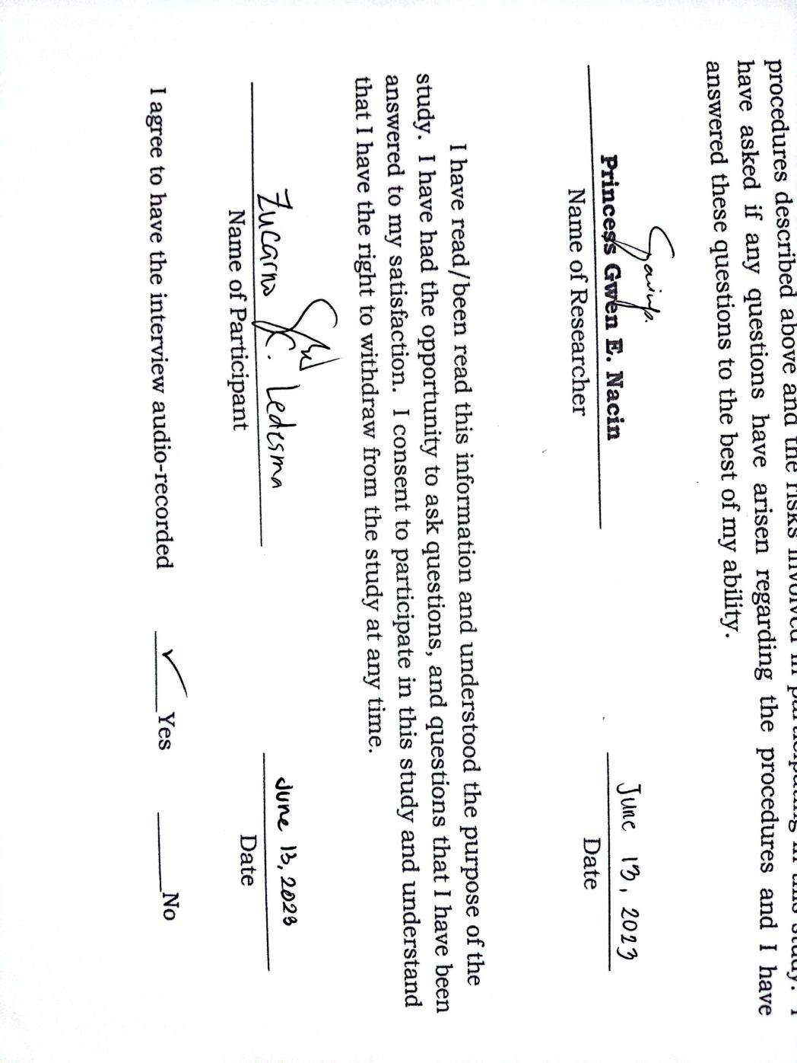

Republic of the Philippines

Region XII

Division of Sultan Kudarat

**Isulan National High School**

Kalawag II, Isulan, Sultan Kudarat

School Year 2022-2023

**Informed Consent**

We are from **Grade 11 HUMSS 3** of Isulan National High School, Isulan, Sultan Kudarat. We invite you to participate in the study “**TEACHERS’ BARRIERS AND CHALLENGES IN WRITING ACTION RESEARCH**”. The goal of this study is to better understand the barriers and challenges faced by the teachers of Isulan National High School in writing action research. By participating in this study, you will be helping us to understand the challenges and experiences of teachers when writing action research.

This study consists of doing a single interview.  The interview you will do with us shall take place in a private location of your choice and shall last approximately thirty minutes.  In the interview, we shall ask for your challenges and experiences when writing action research. Your ideas shall help us identify and refine themes to be explored later in interviews.

Participation in this study is completely voluntary; it is entirely up to you to choose to participate or not to participate.  You can choose to leave this study at any time.  Nothing will happen if you decide to stop.

With your permission, we would like to audio record the interview.  The audio recordings will be used in writing up the interview, to help make sure the write-up is accurate and complete.  Only members of the research team shall have access to the recordings.  The recording will be erased from the recorder as soon as it is transferred onto the computer.  The computer files of the audio-recordings will be password protected during the study and deleted at the end of the study.  Refusing the recording does not mean you cannot participate in the study.

The risks of participating in this study are minimal.  It is possible that you might get tired during the interview.  You may find some of the questions uncomfortable or hard to answer.  If this happens, we can discuss the situation, take a break, or stop.  If you choose to stop, we can either finish the interview another day or you can end your participation in the study.

This research is intended to help us understand the barriers and challenges faced by teachers when writing action research. The alternative to participating in the study is not to participate. There shall be no compensation for your participation in this study. Your privacy is protected as a participant in this study.  There will be a number rather than your name on copies of your interview.  None of the information you give us will be shared with anyone outside the research project.  Your name will not be used in any written reports or published articles that result from this project.

Though unlikely, there is always a chance of breach of confidentiality when taking part in a research study.  We shall make every effort to protect you from this risk.  Every effort will be made to ensure that descriptions of you as an individual in reports or articles are done in ways that mask your identity.

Your participation in this study is voluntary and you have the right to refuse to participate.  If you change your mind about participating at any time, including during the interview, you have the right to withdraw.

If you have questions about this research, you may contact Princess Gwen E. Nacin, the Team Leader on mobile number:  09677108412 or you may visit them at their classroom.

I have fully explained to the participant the nature and purpose of the procedures described above and the risks involved in participating in this study.  I have asked if any questions have arisen regarding the procedures and I have answered these questions to the best of my ability.

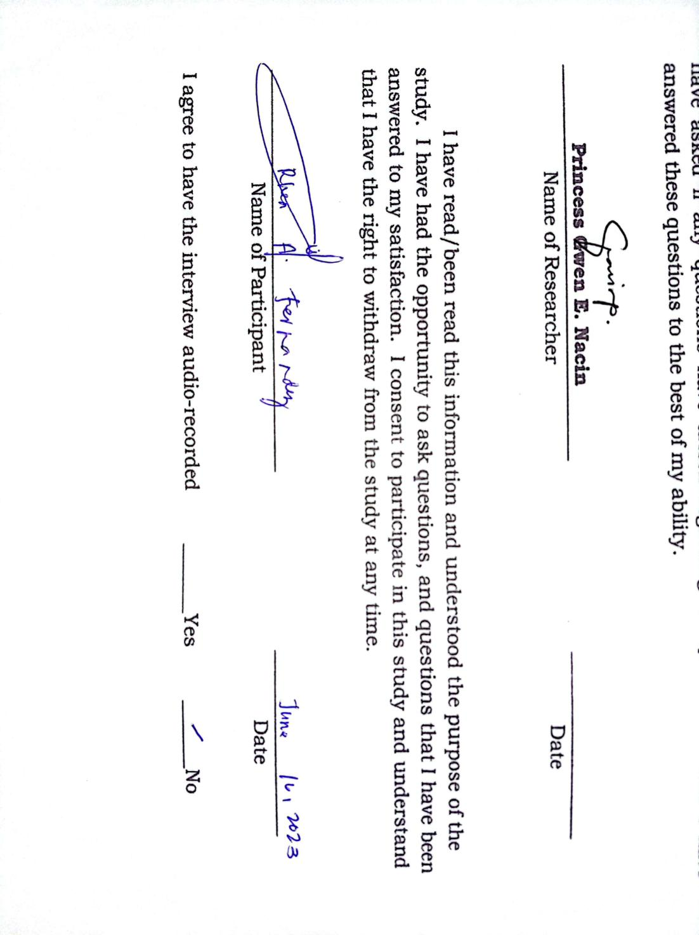

Republic of the Philippines

Region XII

Division of Sultan Kudarat

**Isulan National High School**

Kalawag II, Isulan, Sultan Kudarat

School Year 2022-2023

**Informed Consent**

We are from **Grade 11 HUMSS 3** of Isulan National High School, Isulan, Sultan Kudarat. We invite you to participate in the study “**TEACHERS’ BARRIERS AND CHALLENGES IN WRITING ACTION RESEARCH**”. The goal of this study is to better understand the barriers and challenges faced by the teachers of Isulan National High School in writing action research. By participating in this study, you will be helping us to understand the challenges and experiences of teachers when writing action research.

This study consists of doing a single interview.  The interview you will do with us shall take place in a private location of your choice and shall last approximately thirty minutes.  In the interview, we shall ask for your challenges and experiences when writing action research. Your ideas shall help us identify and refine themes to be explored later in interviews.

Participation in this study is completely voluntary; it is entirely up to you to choose to participate or not to participate.  You can choose to leave this study at any time.  Nothing will happen if you decide to stop.

With your permission, we would like to audio record the interview.  The audio recordings will be used in writing up the interview, to help make sure the write-up is accurate and complete.  Only members of the research team shall have access to the recordings.  The recording will be erased from the recorder as soon as it is transferred onto the computer.  The computer files of the audio-recordings will be password protected during the study and deleted at the end of the study.  Refusing the recording does not mean you cannot participate in the study.

The risks of participating in this study are minimal.  It is possible that you might get tired during the interview.  You may find some of the questions uncomfortable or hard to answer.  If this happens, we can discuss the situation, take a break, or stop.  If you choose to stop, we can either finish the interview another day or you can end your participation in the study.

This research is intended to help us understand the barriers and challenges faced by teachers when writing action research. The alternative to participating in the study is not to participate. There shall be no compensation for your participation in this study. Your privacy is protected as a participant in this study.  There will be a number rather than your name on copies of your interview.  None of the information you give us will be shared with anyone outside the research project.  Your name will not be used in any written reports or published articles that result from this project.

Though unlikely, there is always a chance of breach of confidentiality when taking part in a research study.  We shall make every effort to protect you from this risk.  Every effort will be made to ensure that descriptions of you as an individual in reports or articles are done in ways that mask your identity.

Your participation in this study is voluntary and you have the right to refuse to participate.  If you change your mind about participating at any time, including during the interview, you have the right to withdraw.

If you have questions about this research, you may contact Princess Gwen E. Nacin, the Team Leader on mobile number:  09677108412 or you may visit them at their classroom.

I have fully explained to the participant the nature and purpose of the procedures described above and the risks involved in participating in this study.  I have asked if any questions have arisen regarding the procedures and I have answered these questions to the best of my ability.

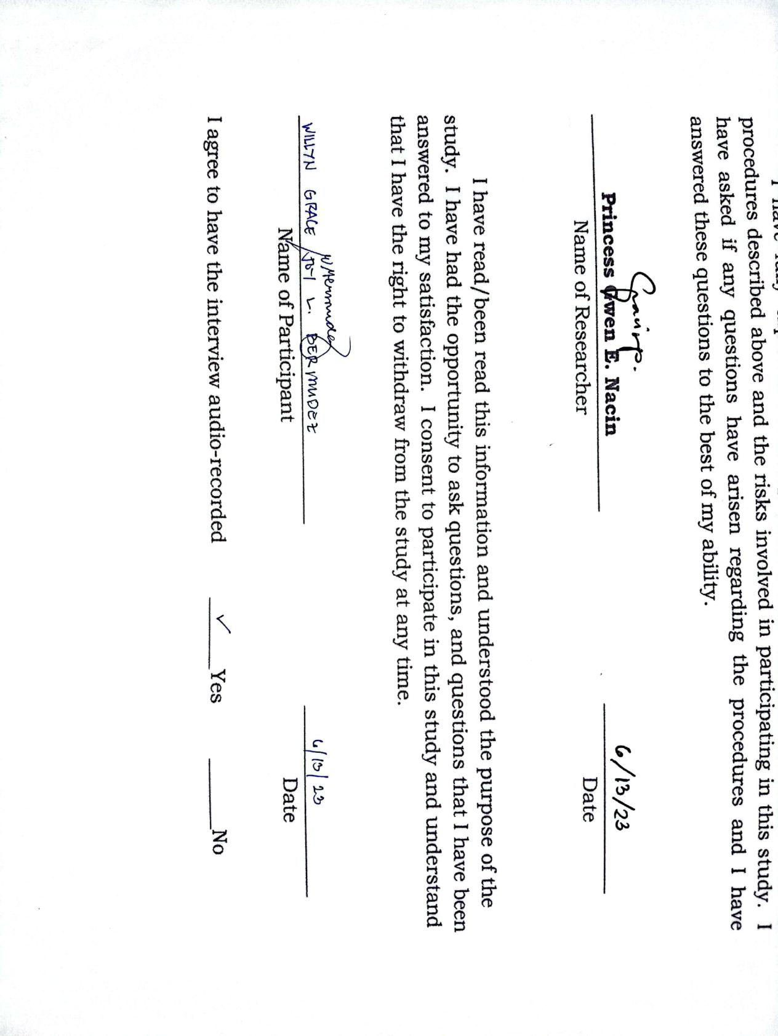

Republic of the Philippines

Region XII

Division of Sultan Kudarat

**Isulan National High School**

Kalawag II, Isulan, Sultan Kudarat

School Year 2022-2023

**Informed Consent**

We are from **Grade 11 HUMSS 3** of Isulan National High School, Isulan, Sultan Kudarat. We invite you to participate in the study “**TEACHERS’ BARRIERS AND CHALLENGES IN WRITING ACTION RESEARCH**”. The goal of this study is to better understand the barriers and challenges faced by the teachers of Isulan National High School in writing action research. By participating in this study, you will be helping us to understand the challenges and experiences of teachers when writing action research.

This study consists of doing a single interview.  The interview you will do with us shall take place in a private location of your choice and shall last approximately thirty minutes.  In the interview, we shall ask for your challenges and experiences when writing action research. Your ideas shall help us identify and refine themes to be explored later in interviews.

Participation in this study is completely voluntary; it is entirely up to you to choose to participate or not to participate.  You can choose to leave this study at any time.  Nothing will happen if you decide to stop.

With your permission, we would like to audio record the interview.  The audio recordings will be used in writing up the interview, to help make sure the write-up is accurate and complete.  Only members of the research team shall have access to the recordings.  The recording will be erased from the recorder as soon as it is transferred onto the computer.  The computer files of the audio-recordings will be password protected during the study and deleted at the end of the study.  Refusing the recording does not mean you cannot participate in the study.

The risks of participating in this study are minimal.  It is possible that you might get tired during the interview.  You may find some of the questions uncomfortable or hard to answer.  If this happens, we can discuss the situation, take a break, or stop.  If you choose to stop, we can either finish the interview another day or you can end your participation in the study.

This research is intended to help us understand the barriers and challenges faced by teachers when writing action research. The alternative to participating in the study is not to participate. There shall be no compensation for your participation in this study. Your privacy is protected as a participant in this study.  There will be a number rather than your name on copies of your interview.  None of the information you give us will be shared with anyone outside the research project.  Your name will not be used in any written reports or published articles that result from this project.

Though unlikely, there is always a chance of breach of confidentiality when taking part in a research study.  We shall make every effort to protect you from this risk.  Every effort will be made to ensure that descriptions of you as an individual in reports or articles are done in ways that mask your identity.

Your participation in this study is voluntary and you have the right to refuse to participate.  If you change your mind about participating at any time, including during the interview, you have the right to withdraw.

If you have questions about this research, you may contact Princess Gwen E. Nacin, the Team Leader on mobile number:  09677108412 or you may visit them at their classroom.

I have fully explained to the participant the nature and purpose of the procedures described above and the risks involved in participating in this study.  I have asked if any questions have arisen regarding the procedures and I have answered these questions to the best of my ability.

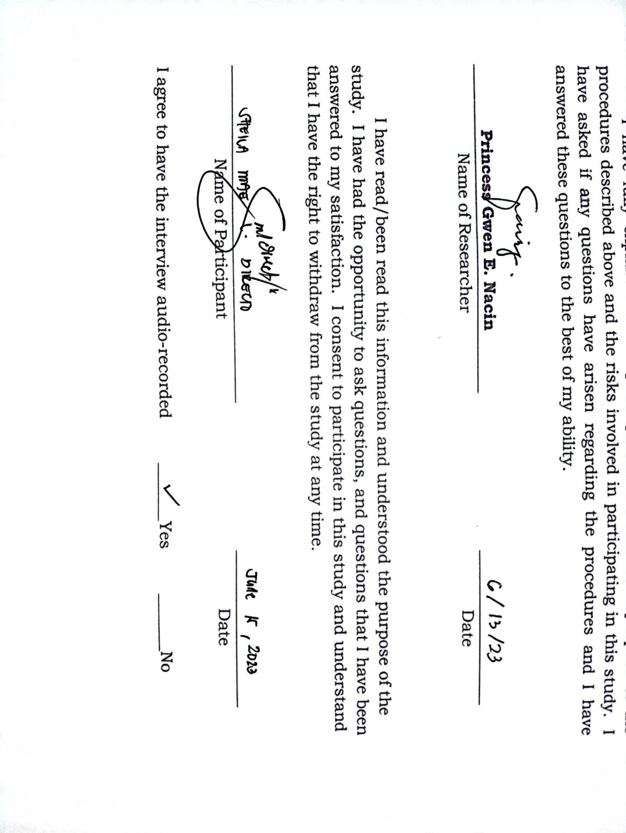

Republic of the Philippines

Region XII

Division of Sultan Kudarat

**Isulan National High School**

Kalawag II, Isulan, Sultan Kudarat

School Year 2022-2023

**Informed Consent**

We are from **Grade 11 HUMSS 3** of Isulan National High School, Isulan, Sultan Kudarat. We invite you to participate in the study “**TEACHERS’ BARRIERS AND CHALLENGES IN WRITING ACTION RESEARCH**”. The goal of this study is to better understand the barriers and challenges faced by the teachers of Isulan National High School in writing action research. By participating in this study, you will be helping us to understand the challenges and experiences of teachers when writing action research.

This study consists of doing a single interview.  The interview you will do with us shall take place in a private location of your choice and shall last approximately thirty minutes.  In the interview, we shall ask for your challenges and experiences when writing action research. Your ideas shall help us identify and refine themes to be explored later in interviews.

Participation in this study is completely voluntary; it is entirely up to you to choose to participate or not to participate.  You can choose to leave this study at any time.  Nothing will happen if you decide to stop.

With your permission, we would like to audio record the interview.  The audio recordings will be used in writing up the interview, to help make sure the write-up is accurate and complete.  Only members of the research team shall have access to the recordings.  The recording will be erased from the recorder as soon as it is transferred onto the computer.  The computer files of the audio-recordings will be password protected during the study and deleted at the end of the study.  Refusing the recording does not mean you cannot participate in the study.

The risks of participating in this study are minimal.  It is possible that you might get tired during the interview.  You may find some of the questions uncomfortable or hard to answer.  If this happens, we can discuss the situation, take a break, or stop.  If you choose to stop, we can either finish the interview another day or you can end your participation in the study.

This research is intended to help us understand the barriers and challenges faced by teachers when writing action research. The alternative to participating in the study is not to participate. There shall be no compensation for your participation in this study. Your privacy is protected as a participant in this study.  There will be a number rather than your name on copies of your interview.  None of the information you give us will be shared with anyone outside the research project.  Your name will not be used in any written reports or published articles that result from this project.

Though unlikely, there is always a chance of breach of confidentiality when taking part in a research study.  We shall make every effort to protect you from this risk.  Every effort will be made to ensure that descriptions of you as an individual in reports or articles are done in ways that mask your identity.

Your participation in this study is voluntary and you have the right to refuse to participate.  If you change your mind about participating at any time, including during the interview, you have the right to withdraw.

If you have questions about this research, you may contact Princess Gwen E. Nacin, the Team Leader on mobile number:  09677108412 or you may visit them at their classroom.

I have fully explained to the participant the nature and purpose of the procedures described above and the risks involved in participating in this 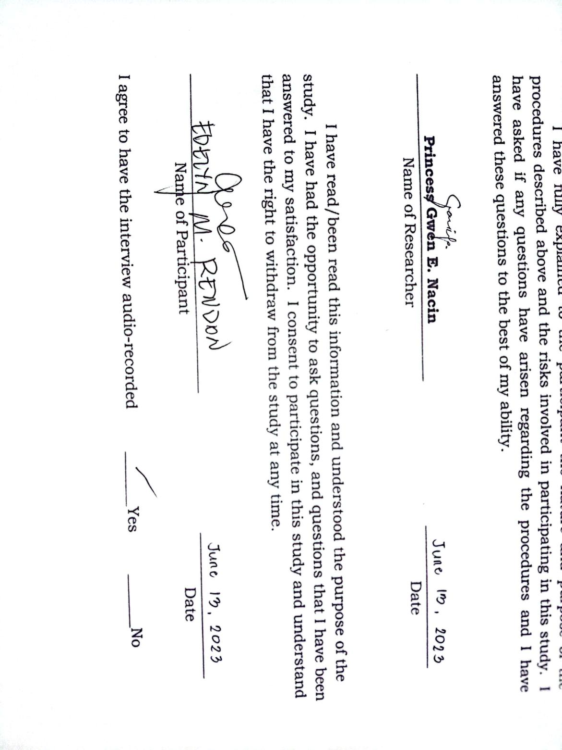study.  I have asked if any questions have arisen regarding the procedures and I have answered these questions to the best of my ability.

Republic of the Philippines

Region XII

Division of Sultan Kudarat

**Isulan National High School**

Kalawag II, Isulan, Sultan Kudarat

School Year 2022-2023

**Informed Consent**

We are from **Grade 11 HUMSS 3** of Isulan National High School, Isulan, Sultan Kudarat. We invite you to participate in the study “**TEACHERS’ BARRIERS AND CHALLENGES IN WRITING ACTION RESEARCH**”. The goal of this study is to better understand the barriers and challenges faced by the teachers of Isulan National High School in writing action research. By participating in this study, you will be helping us to understand the challenges and experiences of teachers when writing action research.

This study consists of doing a single interview.  The interview you will do with us shall take place in a private location of your choice and shall last approximately thirty minutes.  In the interview, we shall ask for your challenges and experiences when writing action research. Your ideas shall help us identify and refine themes to be explored later in interviews.

Participation in this study is completely voluntary; it is entirely up to you to choose to participate or not to participate.  You can choose to leave this study at any time.  Nothing will happen if you decide to stop.

With your permission, we would like to audio record the interview.  The audio recordings will be used in writing up the interview, to help make sure the write-up is accurate and complete.  Only members of the research team shall have access to the recordings.  The recording will be erased from the recorder as soon as it is transferred onto the computer.  The computer files of the audio-recordings will be password protected during the study and deleted at the end of the study.  Refusing the recording does not mean you cannot participate in the study.

The risks of participating in this study are minimal.  It is possible that you might get tired during the interview.  You may find some of the questions uncomfortable or hard to answer.  If this happens, we can discuss the situation, take a break, or stop.  If you choose to stop, we can either finish the interview another day or you can end your participation in the study.

This research is intended to help us understand the barriers and challenges faced by teachers when writing action research. The alternative to participating in the study is not to participate. There shall be no compensation for your participation inthis study. Your privacy is protected as a participant in this study.  There will be a number rather than your name on copies of your interview.  None of the information you give us will be shared with anyone outside the research project.  Your name will not be used in any written reports or published articles that result from this project.

Though unlikely, there is always a chance of breach of confidentiality when taking part in a research study.  We shall make every effort to protect you from this risk.  Every effort will be made to ensure that descriptions of you as an individual in reports or articles are done in ways that mask your identity.

Your participation in this study is voluntary and you have the right to refuse to participate.  If you change your mind about participating at any time, including during the interview, you have the right to withdraw.

If you have questions about this research, you may contact Princess Gwen E. Nacin, the Team Leader on mobile number:  09677108412 or you may visit them at their classroom.

I have fully explained to the participant the nature and purpose of the procedures described above and the risks involved in participating in this study.  I have asked if any questions have arisen regarding the procedures and I have answered these questions to the best of my ability.

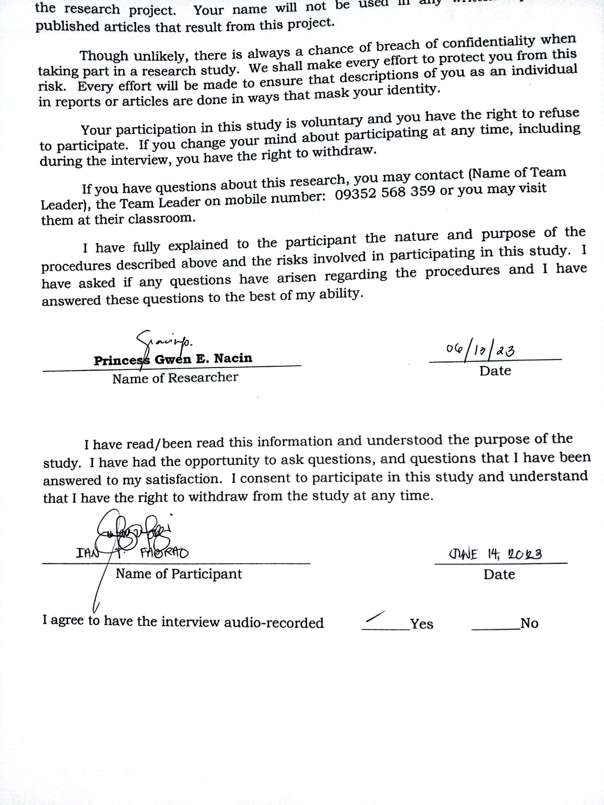

|  |  |  |  |  |
| --- | --- | --- | --- | --- |
| **APPENDIX D**  **Thematic Narrative Analysis**  **Question**   1. What are the barriers and challenges faced by Isulan National High School Teachers’ in writing action     2. How do teachers overcome the barrier and challenges of implementing action research in their teaching practice? | **Significant**  **Statement**  P1: “The different barriers of teachers in Isulan National High School in making action research hmm are first, lack of time and resources. For me, the main barriers are the lack of time and resources, sometimes, the internet connectivity. Having the lack of time and the lack of resources can cause a lack of interest, especially sa amin na matatanda na and uhm specially also we are not familiar with technology. So nagkakaroon talaga ito ng lose of interest in pursuing action research.” (*The different barriers of teachers in Isulan National High School in making action research hmm are first, lack of time and resources. For me, the main barriers are the lack of time and resources, sometimes, the internet connectivity. Having the lack of time and the lack of resources can cause a lack of interest, especially for us who are elderly, and specially also since we are not familiar with technology. This really results in a loss of interest in pursuing action research)*  P2: “The main barriers I face as a teacher when writing action research we’re time, experience and readiness. The particular challenges I face during the process of doing action research we’re lack of experiences in doing research. Perhaps during my college years, research was not given such importance and also the language became a challenge when doing so because I believe that we need to have a good communication skill when doing a action research. Those barriers such as time uhmm affected me to be able to cope or come up the good research study because for us teacher uhmm, we have limited time and knowing that the action research takes time, we really need to focus in order to come up or to finish whatever study will be good.”  P3: “The first barrier for me is really time. Sometimes, we uhm... teachers do not have enough time hmm… due to our classroom responsibilities or preparation for our classes. However, when action research is required, I really need to have overtime. I have to sacrifice some classroom activities to have enough time to conduct action research. Next barriers is uhmm hmm the willingness to do. Teachers some how specially not in line hindi namin linya yung research, hindi ano yun, hindi akma sa capacity namin yung research we are not willing to do it unless it is require pag nirequired ni school, pag nirequired ni subject, pag nirequired ni department that we have to do as a action research that the time na mapipilitan kami gumawa.” (*The first barrier for me is really time. Sometimes, we uhm… teachers do not have enough time hmm due to our classroom responsibilities or preparation for our classes. However, when action research is required, I really need to have overtime. I have to sacrifice some classroom activities to have enough time to conduct action research. Next barriers is the willingness to do. Teachers, particularly those who are not in line with research, we find it difficult to conduct research that is not suitable for our capacity. We are not willing to do it unless it is required by the school, subject, or department as an action research. We only do it when we are forced to do so*)  P4: “What are the main barriers you faced as a teacher in writing action research? Okay. So, Action research is a valuable tool that allows us teachers to reflect teaching practices and improves students learning outcomes. However, their can be visible barriers that teachers faced when writing action research. Based on my experience, some of this barriers include uhm first one is the lack of time. So uhm, teachers often have a busy schedule and which can make it challenging to find time when writing action research also is the lack of research skills to design and conduct research study. So, third barrier for me is limited resources for support needed to conduct research. I also faced a lot of challenges of course the first one is time constrains. Teachers… we find it difficult to find the time to conduct action research particularly if we have a heavy teaching loads or other professional responsibilities. When conducting action research, this lack of support uhm can make it difficult to implement changes based on research findings.”  P5: “Okay. Siguro ano hmm time tapos budget kay costly man talaga amon action research. Kung hindi gid ma-attain ang goal in uhm ano like for example nag set ka sang schedule kung kailan, so due to that madami kasing activity na ginagawa hindi siya masunod. So, hmm most probably hindi masunod ang time ma-delay ang pag ano, pag conduct ng action research.” (*Okay, I think the time. Then, the budget because conducting action research can be costly when doing action research. If we can’t attain the goal in these, like for example you’ve set a schedule of when to do, so due to that we have a large number of activities that we are doing we can’t follow the time that resulted a delay in conducting action research.)*  P6: “For me as a teacher of Isulan National School, among the barriers that I am encountering is the resources the time and financial. Time, we are short of time kasi minsan napakaraming extra task na binibigay sa teacher kaya . Uhm, it will always fall down at saka sa financial. Hmm, the barriers ahm para nagiging unsmart ng study naming kasi hindi siya nagiging timely, parang hindi siya nagiging attainable, hindi siya nagiging measurable kasi kinukulang kami kami talaga sa oras. If the study need to be conducted within 3 months minsan nakaka extend kami, kinukulang sa oras.” *(For me as a teacher of Isulan National High School among the barriers that I`m encountering is the resources as especially the time and financial. Time we are short on time, because sometimes there are so many extra task that is given to the teachers. Uhm… The barriers ahm…It`s like we are being unsmart to our study, because we don’t have time, It`s like is not being attainable, It`s not being measurable because we are really short on time, If the study is to be conducted in 3 months sometimes we need to extend the conducted because we are short on time.)*  P7: “So the barriers of writing action research is dire siya sa budget time mo, kung paano mo siya i-budget ang time mo kay syempre sa kwan hmm loaded ang imo subject at the same time pag weekend sa family naman, may trabaho ka man sa balay nyo kaya stressful sya. So, ang pianka main siguro para sakin is yong time. So, sa challenges is kung may ara sa part ko nga ga isip paano ko siya kay syempre limited lang ang knowledge ko sa action research so maka stress siya, hindi mo gid matapos kay limited lang ang knowledge kag idea mo.” (*So, the barriers, action research it all falls down to budget and your time. On how will you budget your time and of course we are also loaded in your subject at the same time in the weekends in your family you also have work in your home its really stressful. probably the main is the time for me is really the time and at the same time right when there is action research need budget so uhhm it is a possible barrier for me.)*  P8: “The main barriers and phase as a teacher when writing action research is the unprofessional attack or unprofessional critique of some peers may mga peers kase na they give inappropriate critique that focus on the attack to teacher instead of learning. The particular challenges I faced during the process of doing action research is the freedom to participate, The privacy of a person who participate in the research kase may mga families or students kase na…ayaw silang ih publicise or i-share informaly with others, kase ayaw nila ma feel risk sa public specially yung research mo is all about disabilities or behavioral problems of the students.” *(The main barriers and phase as a teacher when writing action research is the unprofessional attack or unprofessional critique of some peers because there are some peers that give inappropriate critique that focus on the attack to teacher instead of learning. The particular challenges i faced during the process of doing action research is the freedom to participate, the privacy of a person who participate 0in the research because there are families or students that don't want to be open in public or don`t want to share with others, because they don`t want to feel at risk in public specially if your research is all about disabilities or behavioral problems of the students.)*  P9: “The main challenges as a teacher faced is lack of resources, this mean that the number of resources is small and sometimes these resources cannot be used. Lack of source majority of the resources need a lot of money which many of them find difficult to set. For me as teachers’ major challenges in writing action research are negative perception and attitudes, lack of conceptual knowledge and nature to critiques, lack of time and resources. The biggest challenges in conducting action research is to collect and analyze the data while you are in the midst of taking action research.  P1: “The different  techniques that I applied to overcome the Barriers and challenges is Time management talaga. Us na teacher marami kaming responsibilities may mga task na naka assign to us and there would be many sacrifices. So, time management is really required and it helps me a lot to pursue different activities katulad nitong Action research. *(The different techniques that I applied to overcome the barriers and challenges is really time management. Us teachers that have many responsibilities there are many tasks that are assign to us and there would be many sacrifices. So, time management is really required and it helps me a lot to pursue different activities just like this action research)*  P2: “I maybe not good in research, in doing action research but as a teacher I need to do so, I need some study, lots of readings and practice to help me face those challenges and barriers. Learning is a process. I maybe not that good or cannot work with my best action research alone because here we are doing it as group right but through time maybe I will able to cope the demand of new system right now even in a young age you are combining a lot of you know performance, outputs that related to research and as well in our age right now, I am 42 and I think this is the right time for me to do something different and believe I that age does not tell us on how will we learn as a individual.  P3:” Time management e aarange ko muna yung schedule ko then I will spend 1 hour after the class ahh itong time nato vacant ko I spend it doing action research formulating questionnaire formulating tools then uhhhmmm at the end of the day naman pag nag uwian na I am also spending to 5:30, 6:30 to do all the task for that research then syempre to overcome naman the motivation na kailangan ko gawin kailangan ko tapusin yung action research. (*Time management I will arrange first my schedule then I will spend 1 hour after class ahh this time it`s my vacant I spend it on action research, formulating questionnaire, formulating tools then at the end of the day when it’s time to go home that I’m also spending 5:30 to 6:30 to do all the task for that research then of course to overcome this the motivation that I need to do is I need to finish the action research.)*  P4:” The benefits of overcoming the challenges in implementing action research in teaching practices, if you have already overcome this challenges and barriers in making an action research it will benefits a lot specially to the teachers who are doing the action research, it helps teachers to become more reflective practitioner through reflection teacher can learned huge strategy for improving student outcomes, and it helps teacher developed a short understanding of teaching and learning this can lead show collaboration among educators in improved communication between teacher and students.”  P5:” So far dapat ang answer dira is time management but as of now parang hindi ko pa na overcome ang barriers nya. kapag magkaroon ng time management tapos magawa nayong action research kay diba dapat may problema na dapat mag gawa kanang gap analysis tapos due to the action research then dapat eh implement mo yun siya para ma solve yung problema so if ever na ma break ang barriers hopefully ma solve ang problem.” (“*So far it is really time management but as of now it`s like I haven’t overcome the barriers yet. If ever I will have time management than I can already write action research like right there`s a problem that needs to analyze the gap than due to the action research then need to implement that so that problem can be solve so if ever that we can break the barriers hopefully the problem can be solve.”)*   P6:” Shall we have, we are scheduling dapat meron siyang time management, tapos it would also be better kung ang admin or nasa office will give us the order ahead of the time para mas mahaba yung time nang month namin to conduct the action research. Among the benefits would be, we will be able to address the barriers of learners in learning the competencies wherein they think are, where they find it difficult to understand.” *(“Shall we have our schedule needs time management, then it would also be better if the admin or the people in the office will give us order ahead of the time, to have a extended time to conduct our action research. Among the benefits would be, will be able to address the barriers of learners in learning the competencies wherein they think are where they find it difficult to understand.”)*  P7:” So the techniques I use to comprehend the action research is to have more knowledge about how to write action research, that I will probably do is to find someone That is a expert in writing action research, I will ask for ideas, knowledge so I can use it when doing action research.”  P8: “The techniques are you should ground yourself in the research and focus and uhm take advantage in using the technology. The benefits of overcoming these challenges in my teaching practice that through this action research can contribute to the body of knowledge and allow us to learn with our actions of course it allows us to adapt the teaching practices that are beneficial to students.”  P9: “As a teacher, time management help me to overcome those barriers and challenges. Time management is essential in action research. By uhm setting specific timelines and hmm schedules help me to overcome those. I also collaborate with others, and uhm hmm like I seek support and also reflecting on the process.” | **Formulated Meaning**   * The teachers of Isulan National High School faced time and financial barriers, leading to unsmart and delayed studies. * The lack of interest arises due to the lack of time, resources, and familiarity with technology, specially among older teachers. * Teachers us the techniques such as time management, learning, seeking, expert guidance, and utilizing technology to overcome barriers and challenges. * Time management plays a vital role in overcoming the barriers. * Budget constrains and difficulty in attaining research goals affect the timely completion of action research. * Lack of experience and research skills pose challenges in conducting action research. Limited resources and support affect the implementation of research findings. | **Theme**   * Time Factor * Support System * Expertise and prior experience Factor * Solution to the Problem * Collaboration and Support * Reflective Practice and Professional Development | **Findings**  The teachers of Isulan National High School have different barriers and challenges that experiencing when they are writing action research.  From the responses of the participants generally, the main barriers faced by teachers in writing action research include a lack of time, resources, and experience. Additionally, some teachers may lack of willingness or interest in conducting research that is not aligned with their expertise or required by the school. Other challenges include limited support and high cost associated with conducting action research. Furthermore, teachers faced difficulties in managing their time effectively and finding a balance between their teaching responsibilities and research.    From the participants responses, Effective time management is the main strategy used to get over barriers and challenges in putting action research into practice. Teachers highlighted the need of setting up particular time slots for duties relating to action research and utilizing breaks to do research-related tasks. However, several informants acknowledged that they were still encountering obstacles and difficulties, showing the need for greater time management abilities. In addition to increasing student results, promoting educator cooperation, and improving teacher-student communication, solving these hurdles will result in practitioners who are more thoughtful about their practice. The informants also emphasized the significance of learning about writing action research, engaging oneself in the field, employing technology, and reflecting on the process. Overall, it was found that effective action research adaptation requires time management, teamwork, ongoing learning, and reflection. |

**APPENDIX E.**

**Documentation**

**Title and Outline Defense**

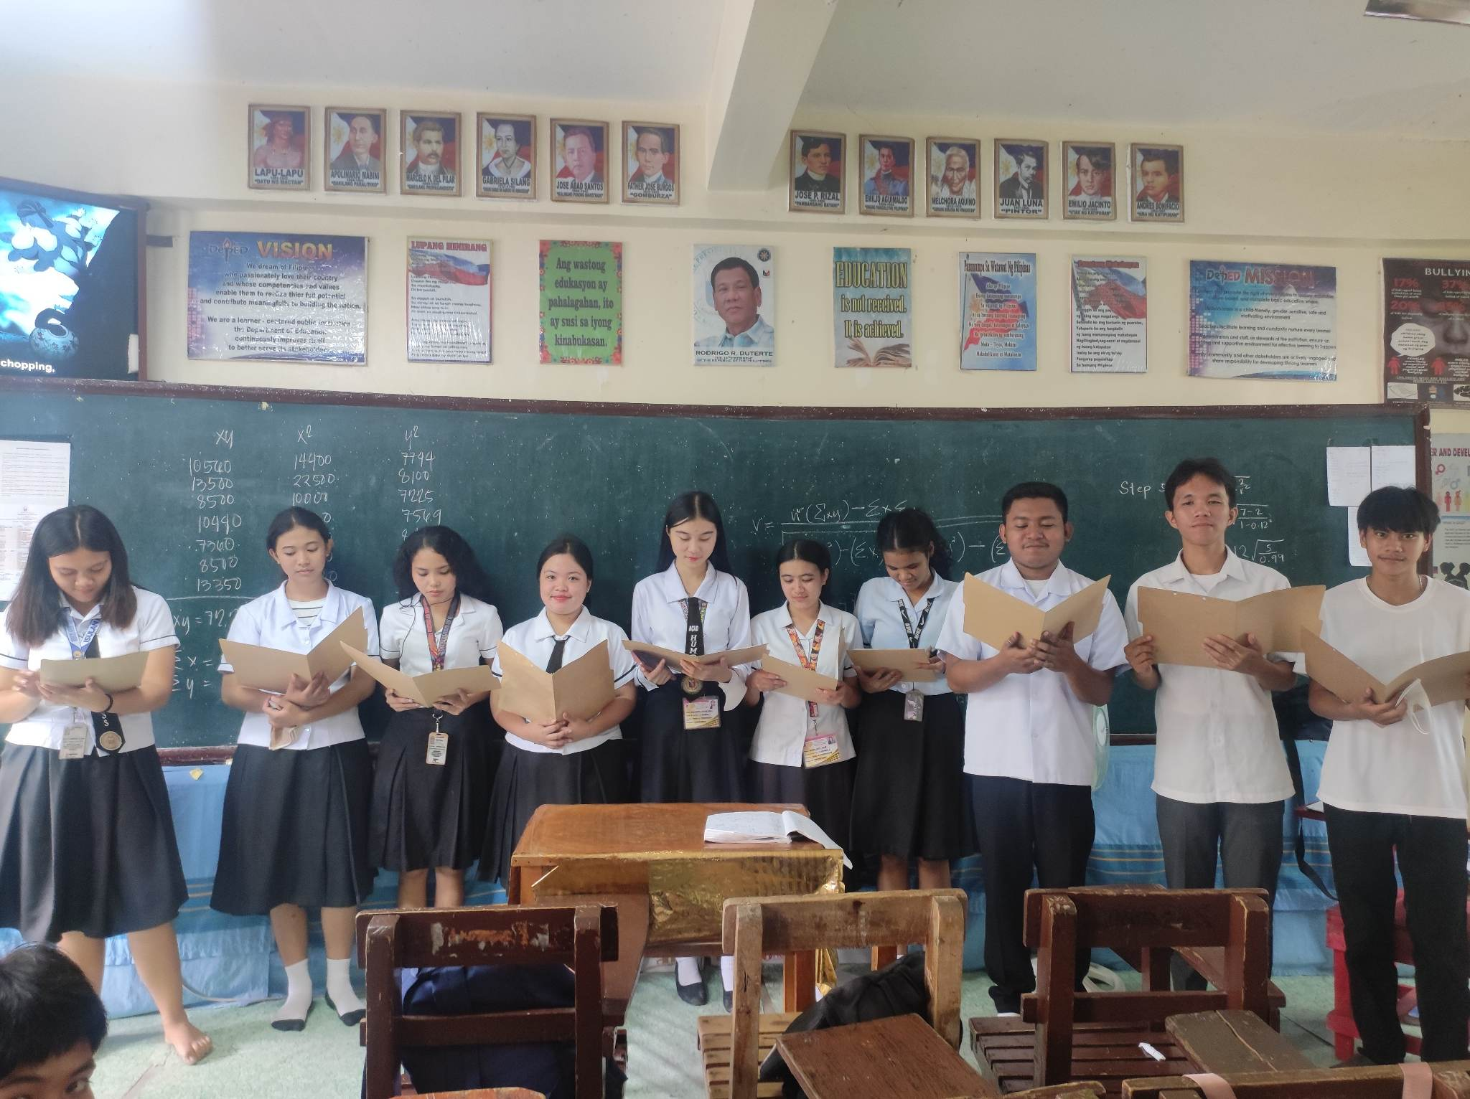

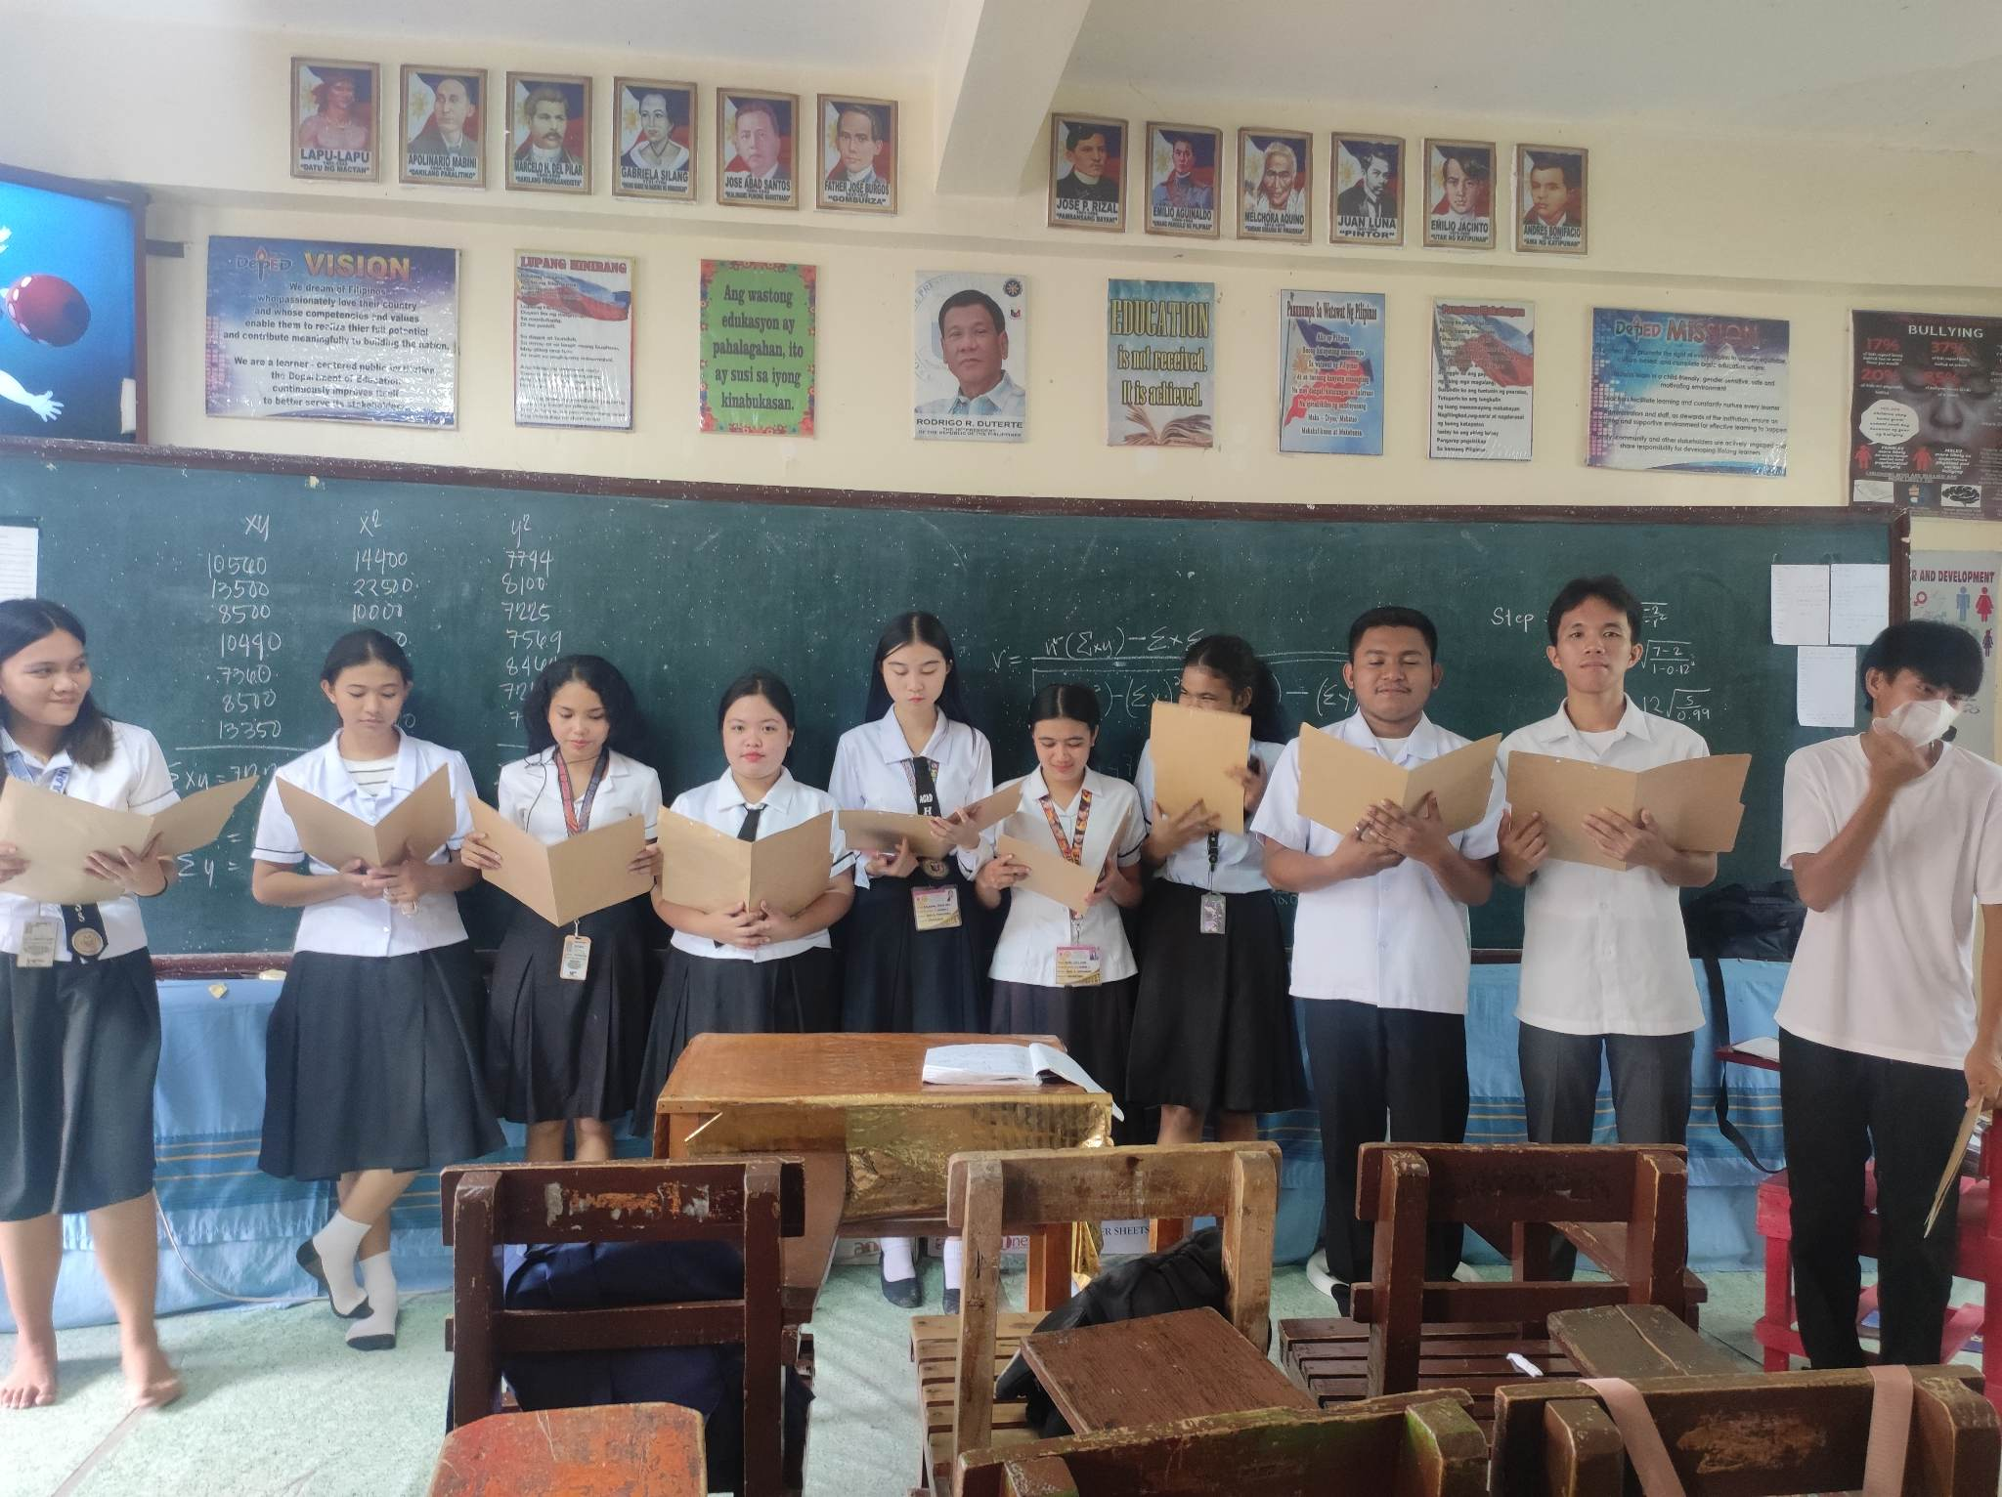





**Outline Defense**

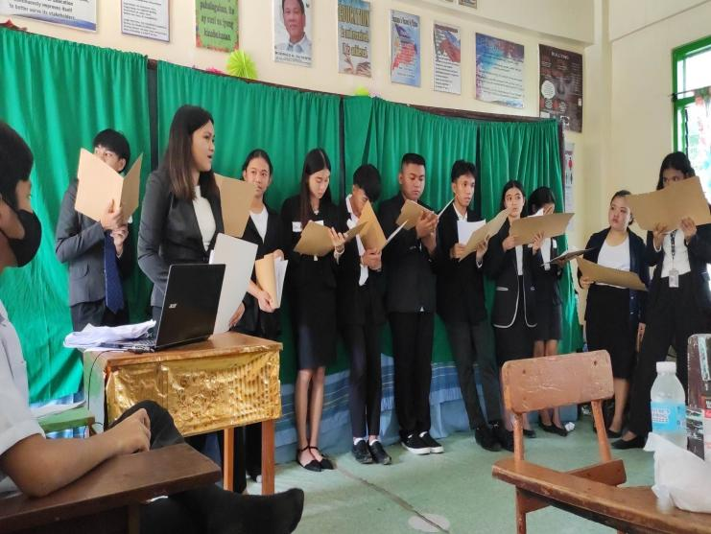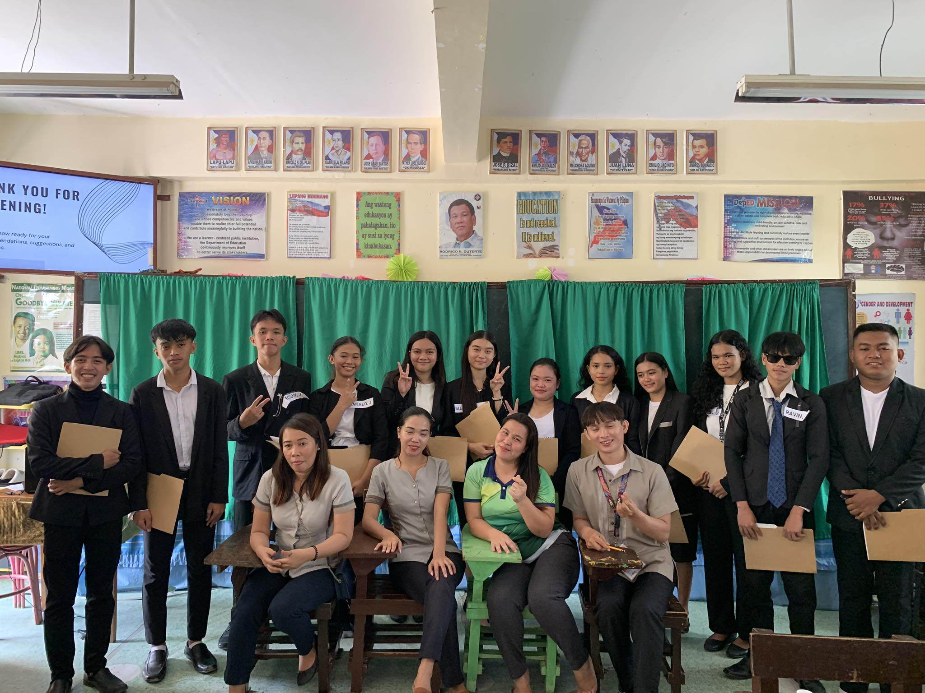

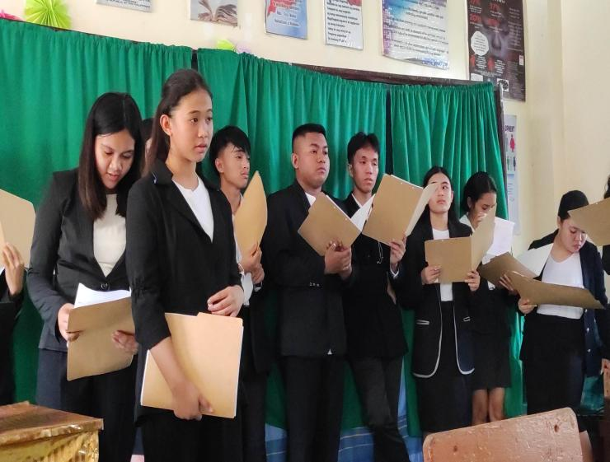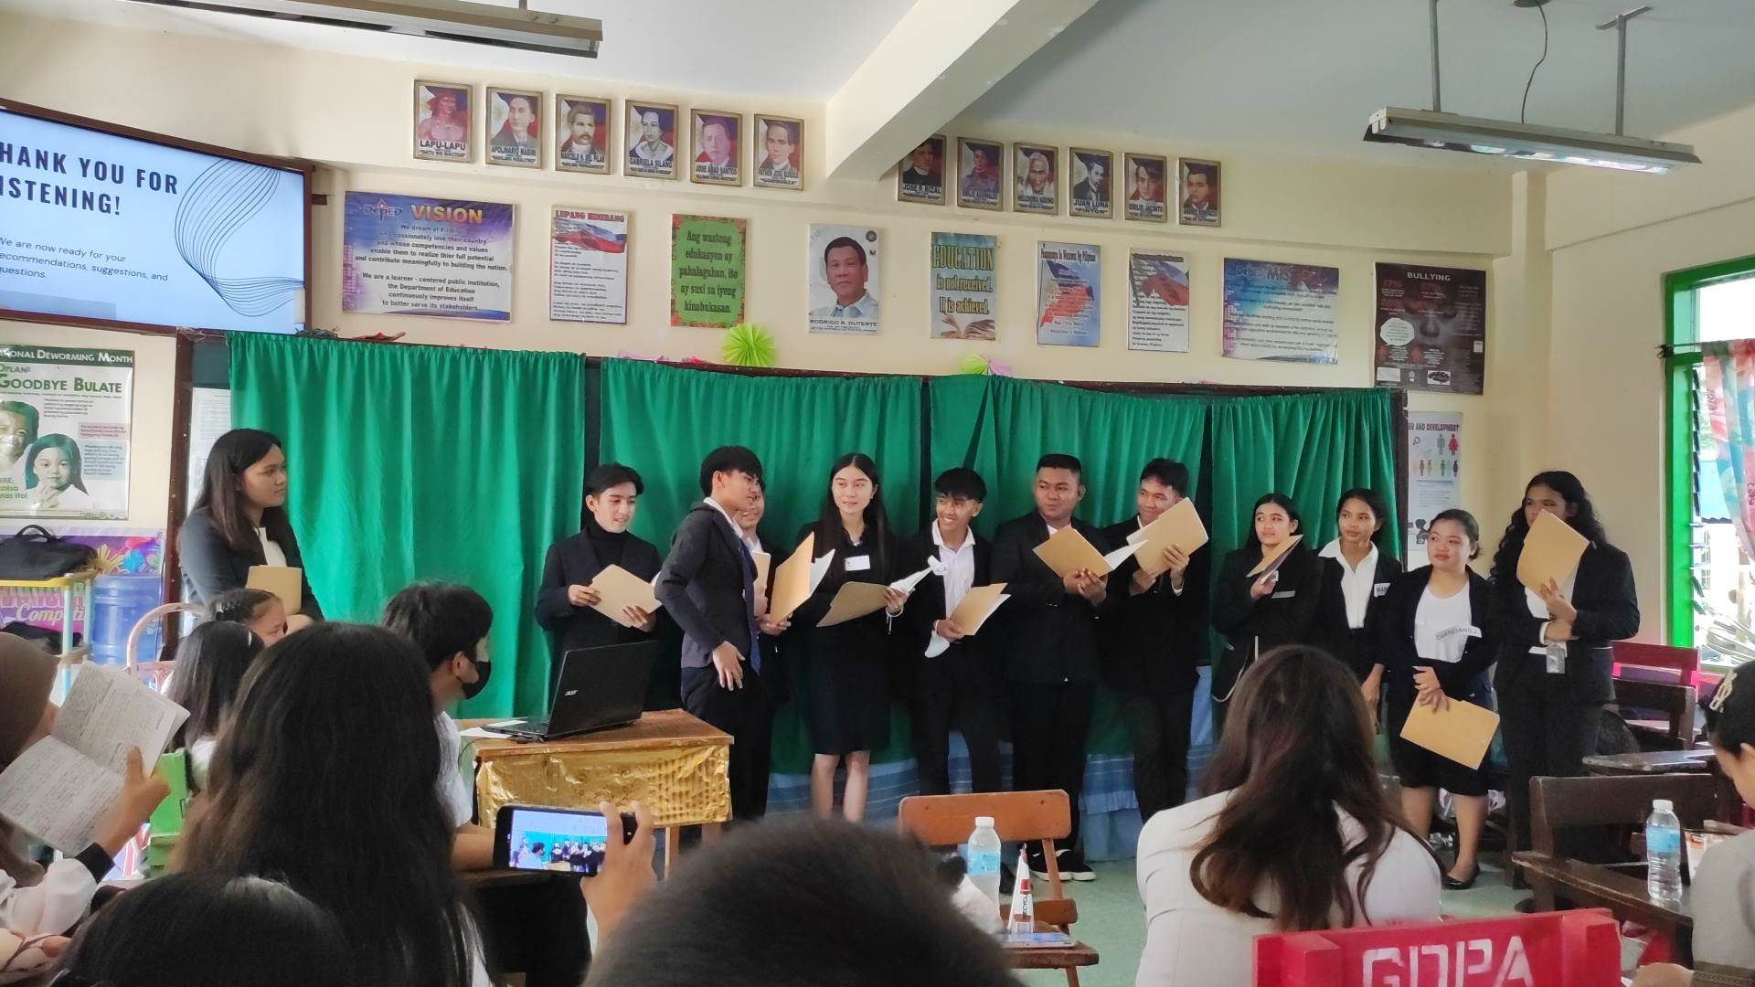

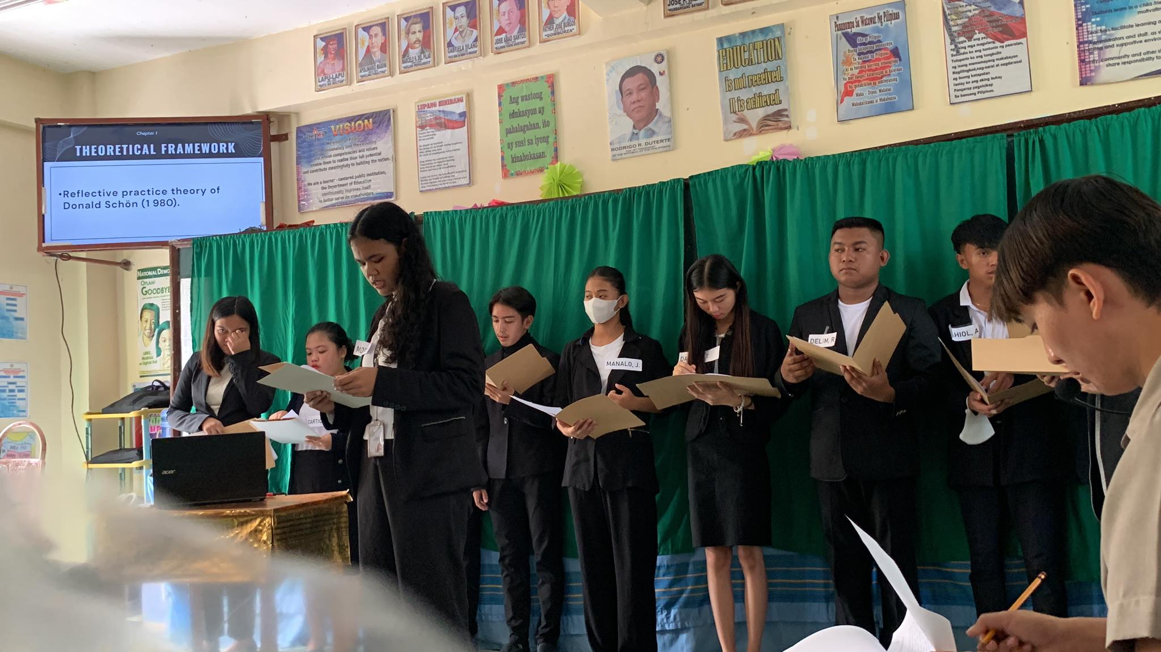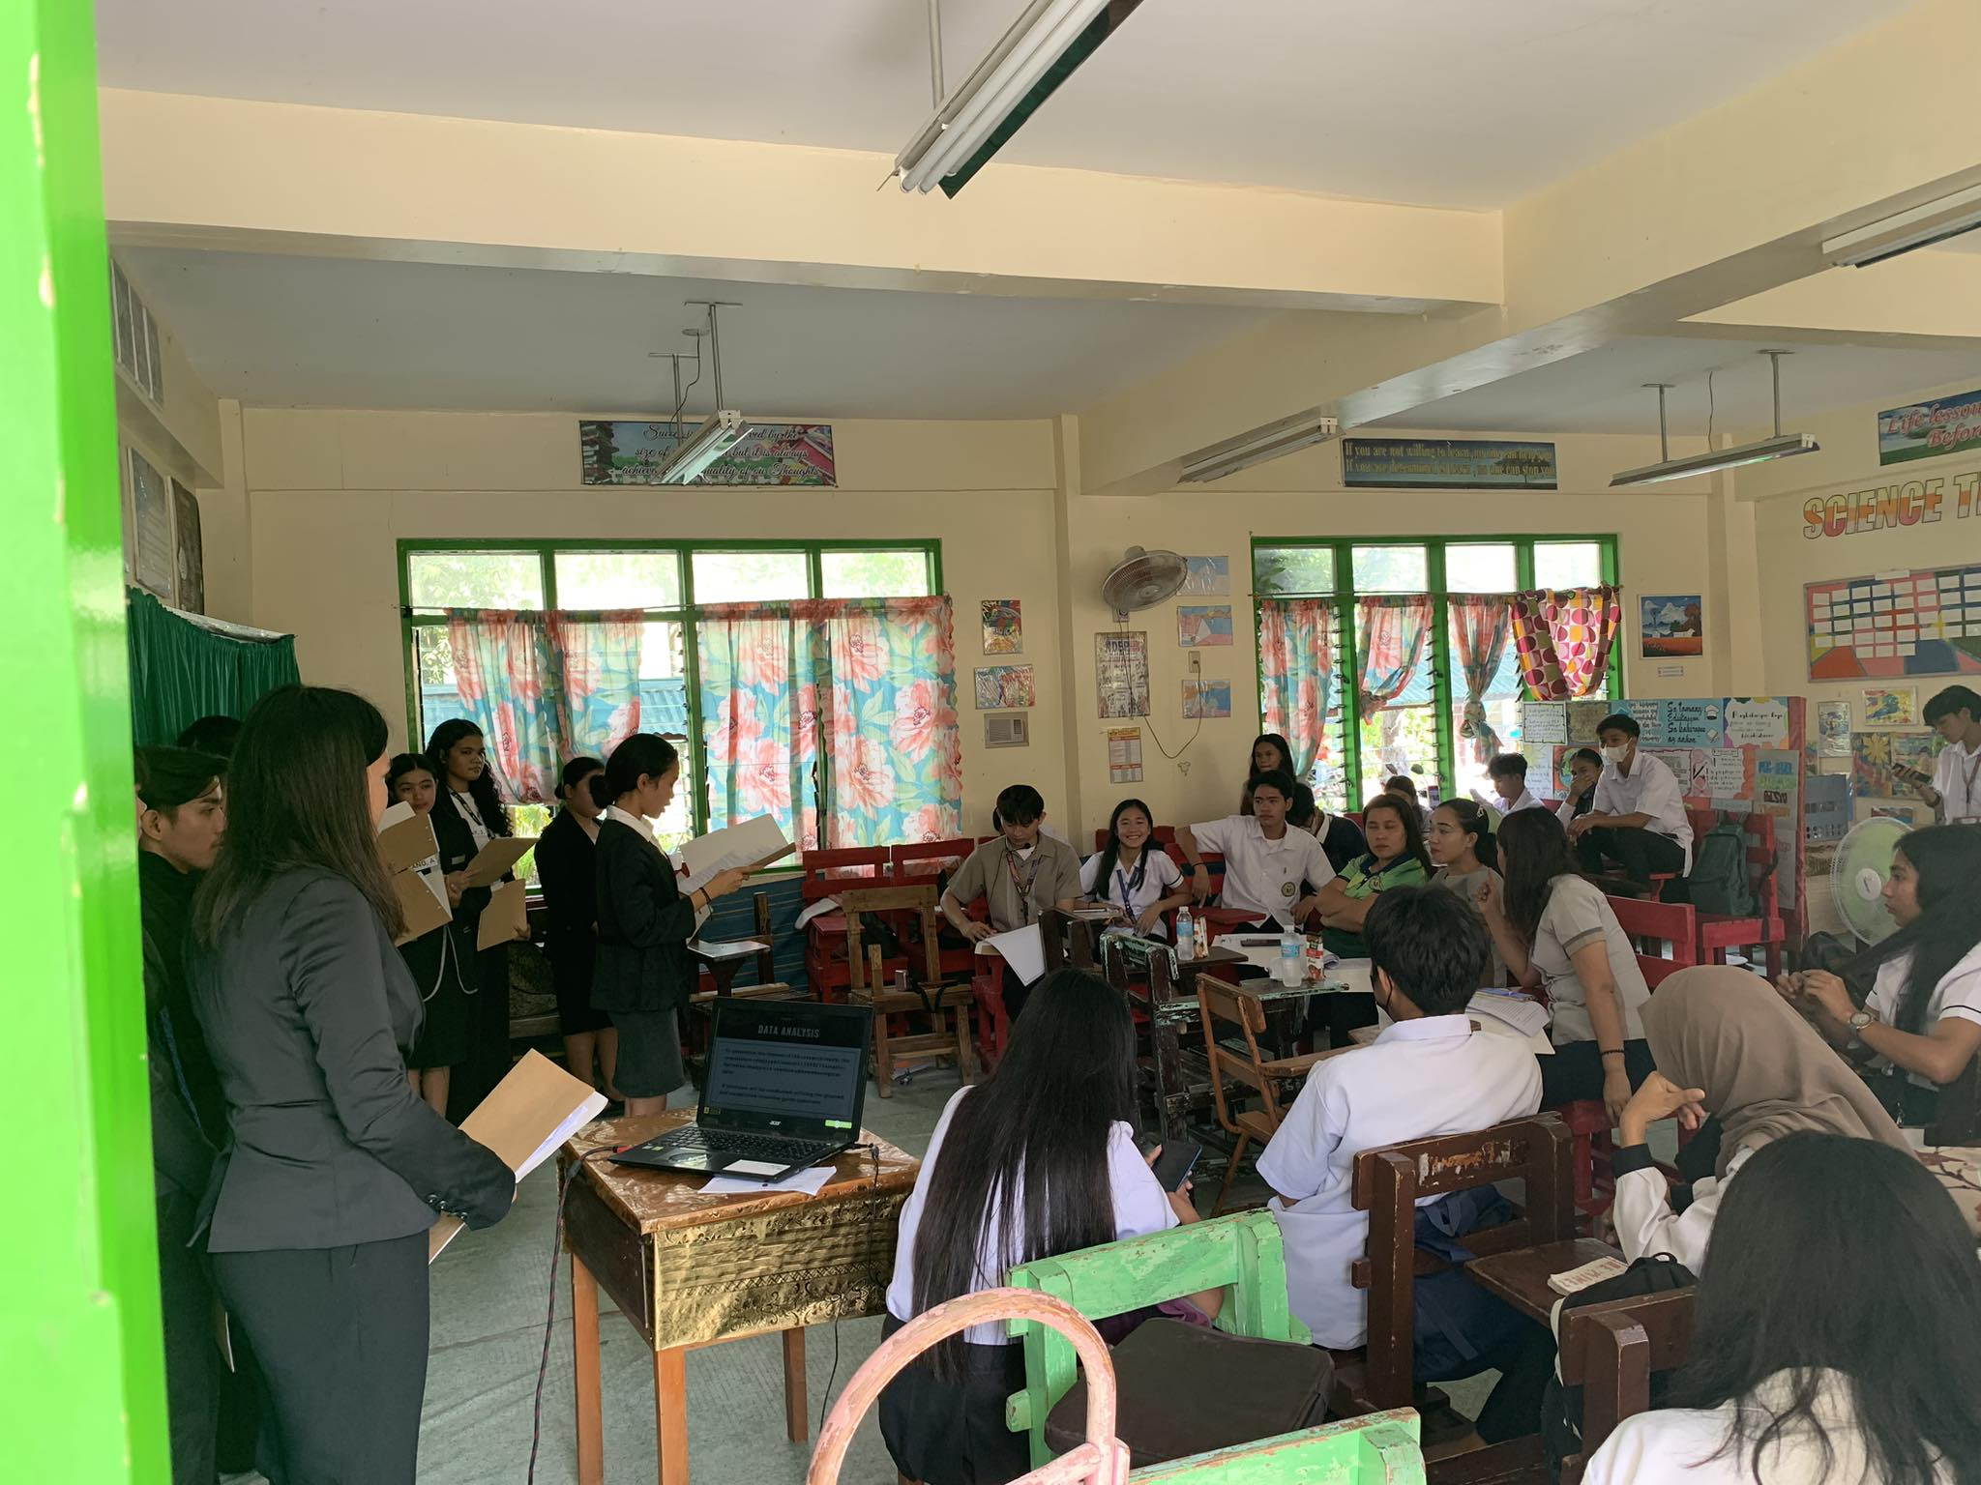

**Finale Defense**

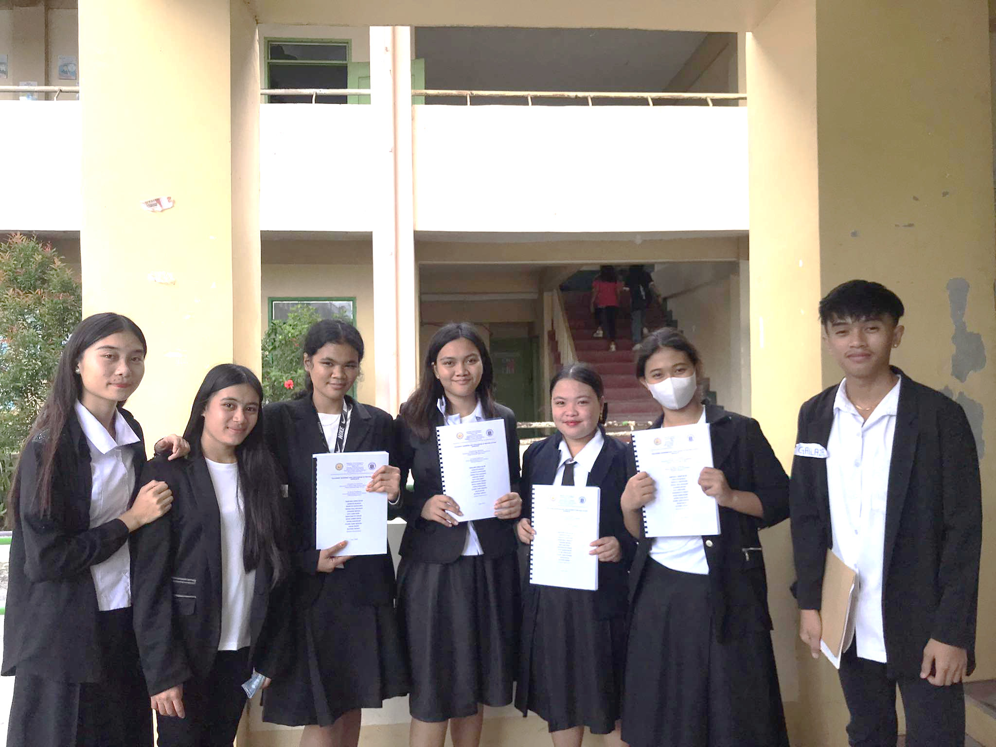

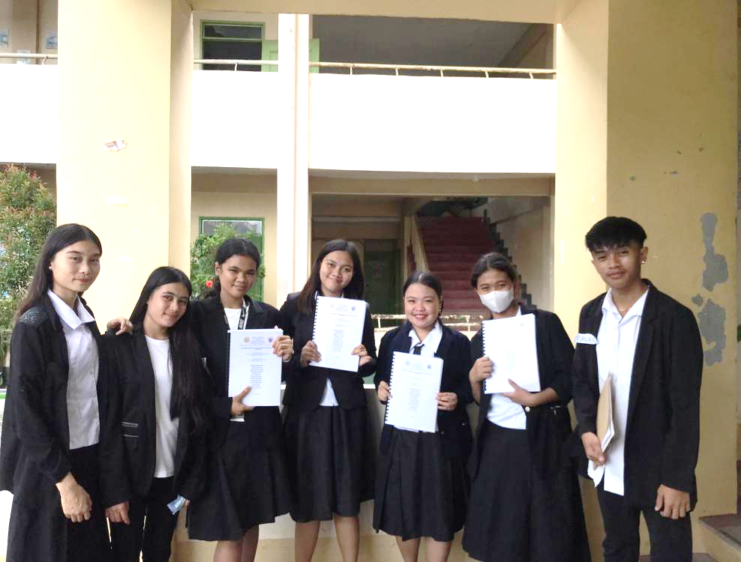

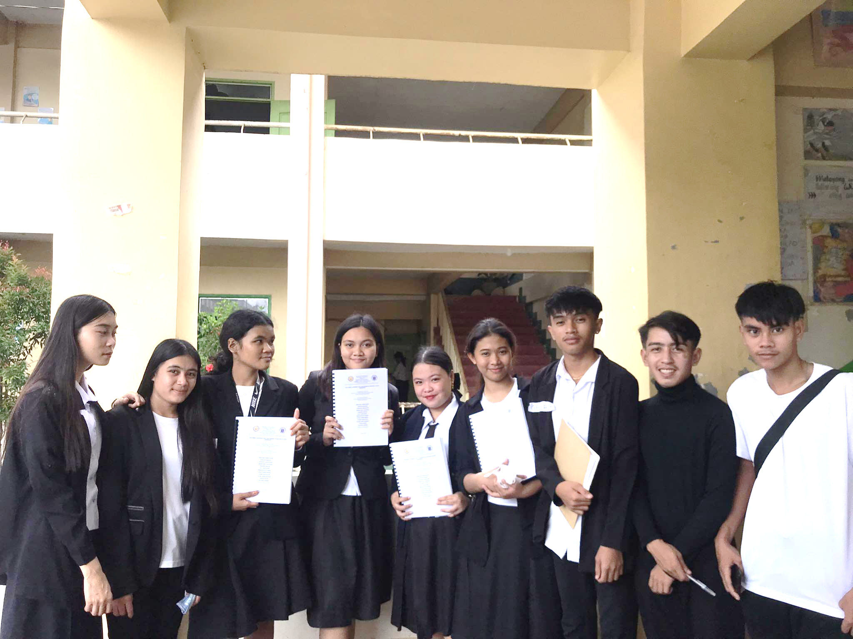

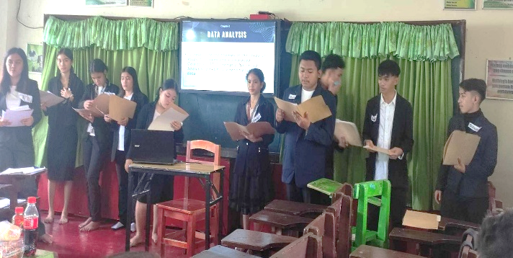

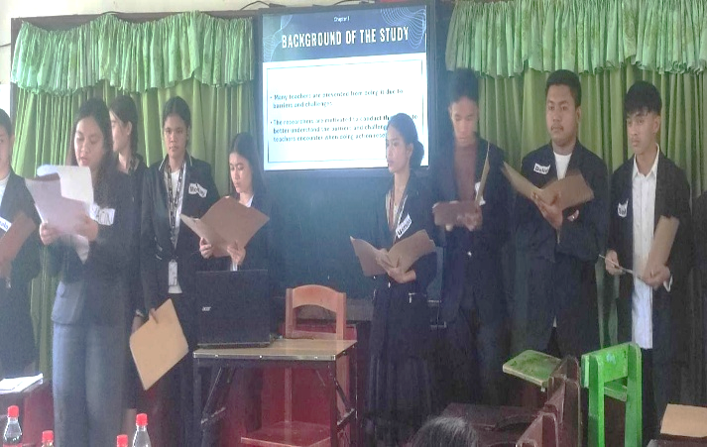

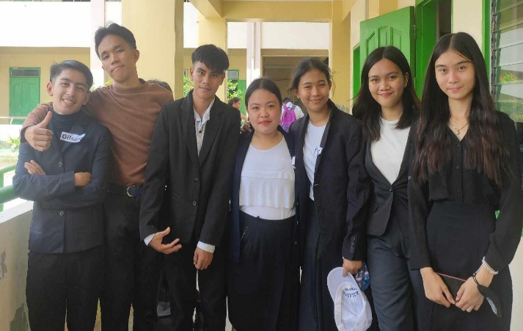

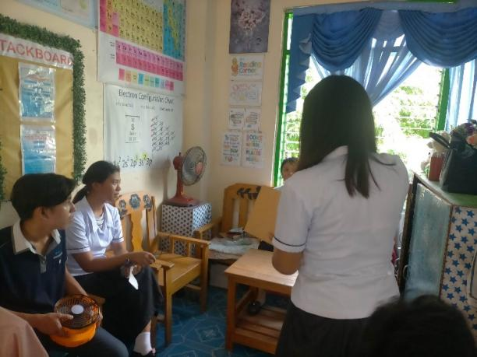

**During the Interview**

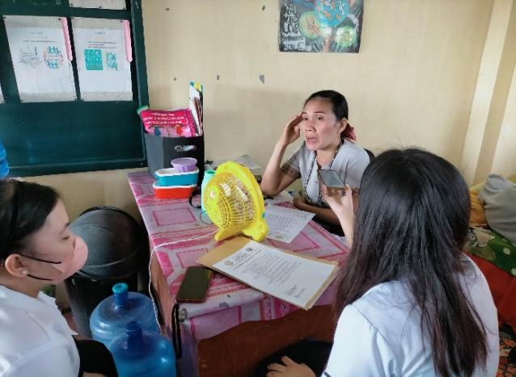

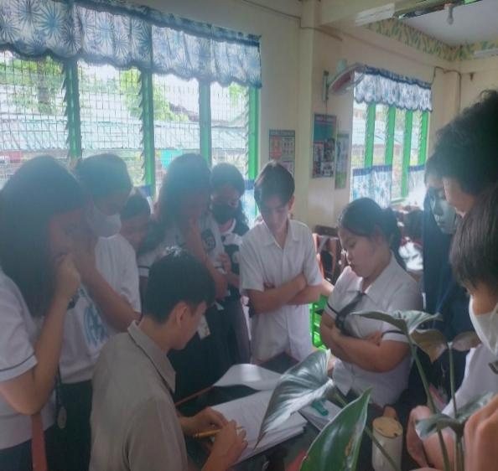

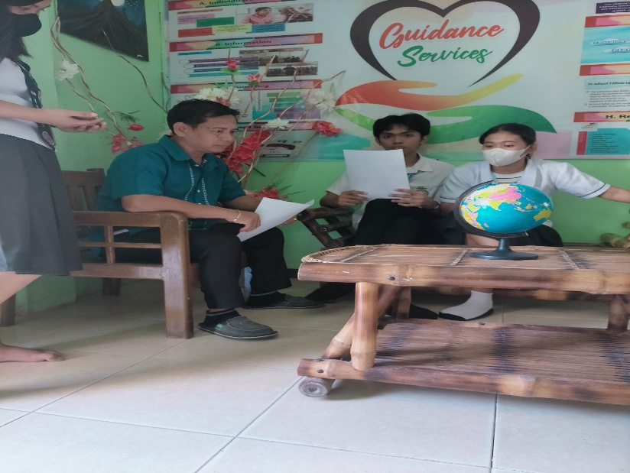

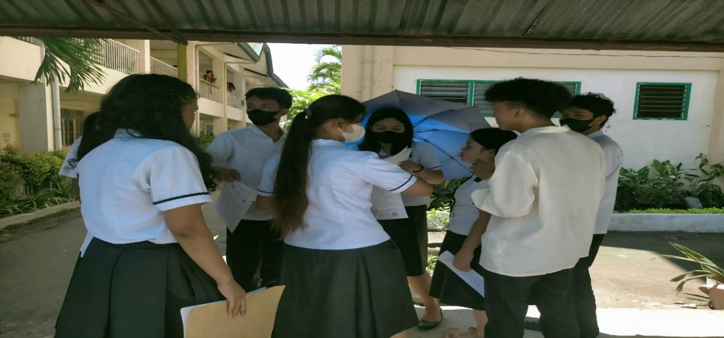

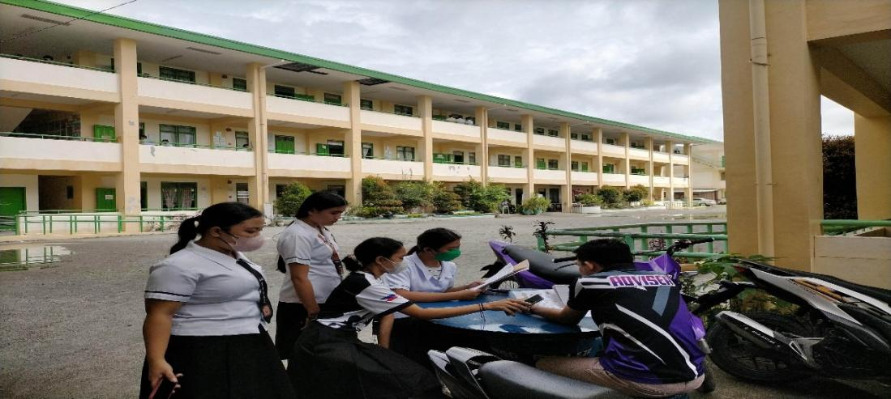

**APPENDIX F**

**CURRICULUM VITAE**

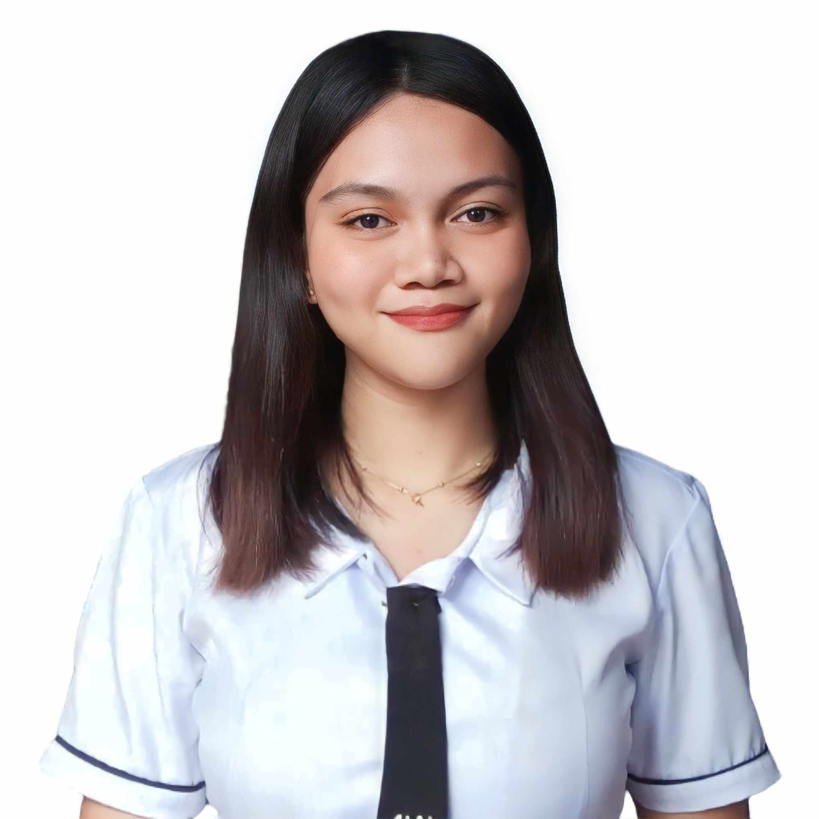

**PERSONAL DATA:**

Name: **PRINCESS GWEN E.**

**NACIN**

Date of Birth: February 23, 2006

Place of Birth: Kalawag II, Isulan,

Sultan Kudarat

Email Address: Hnnnnbnbnbbbbbbbbbbbb. princessgwenedernacin@gmail.com

Father: Ernesto B. Nacin

Mother: Rowena E. Nacin

**EDUCATIONAL** *STRAND:* **Humanities and Social Sciences**

**BACKGROUND** Isulan National High School

Kalawag II, Isulan, Sultan Kudarat

S.Y. 2022-Present

HIGH SCHOOL: Isulan National High School

Kalawag II, Isulan Sultan Kudarat

2018-2022

ELEMENTARY: Kalawag Central School

Kalawag I, Isulan, Sultan Kudarat

2012-2018

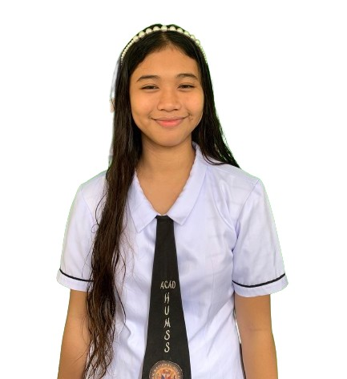

**PERSONAL DATA:**

Name: **JONALYN D. MANALO**

Date of Birth: June 29, 2006

Place of Birth: Kalawag II, Isulan,

Sultan Kudarat

Email Address: qurisaiko@gmail.com

Father: Victor E. Manalo

Mother: Marcelina D. Manalo

**EDUCATIONAL** *STRAND:* **Humanities and Social Sciences**

**BACKGROUND** Isulan National High School

Kalawag II, Isulan, Sultan Kudarat S.Y. 2022-Present

HIGH SCHOOL: Isulan National High School

Kalawag II, Isulan, Sultan Kudarat 2018-2022

ELEMENTARY: Kalawag Central School

Kalawag I, Isulan, Sultan Kudarat

2012-2018

**PERSONAL DATA:**

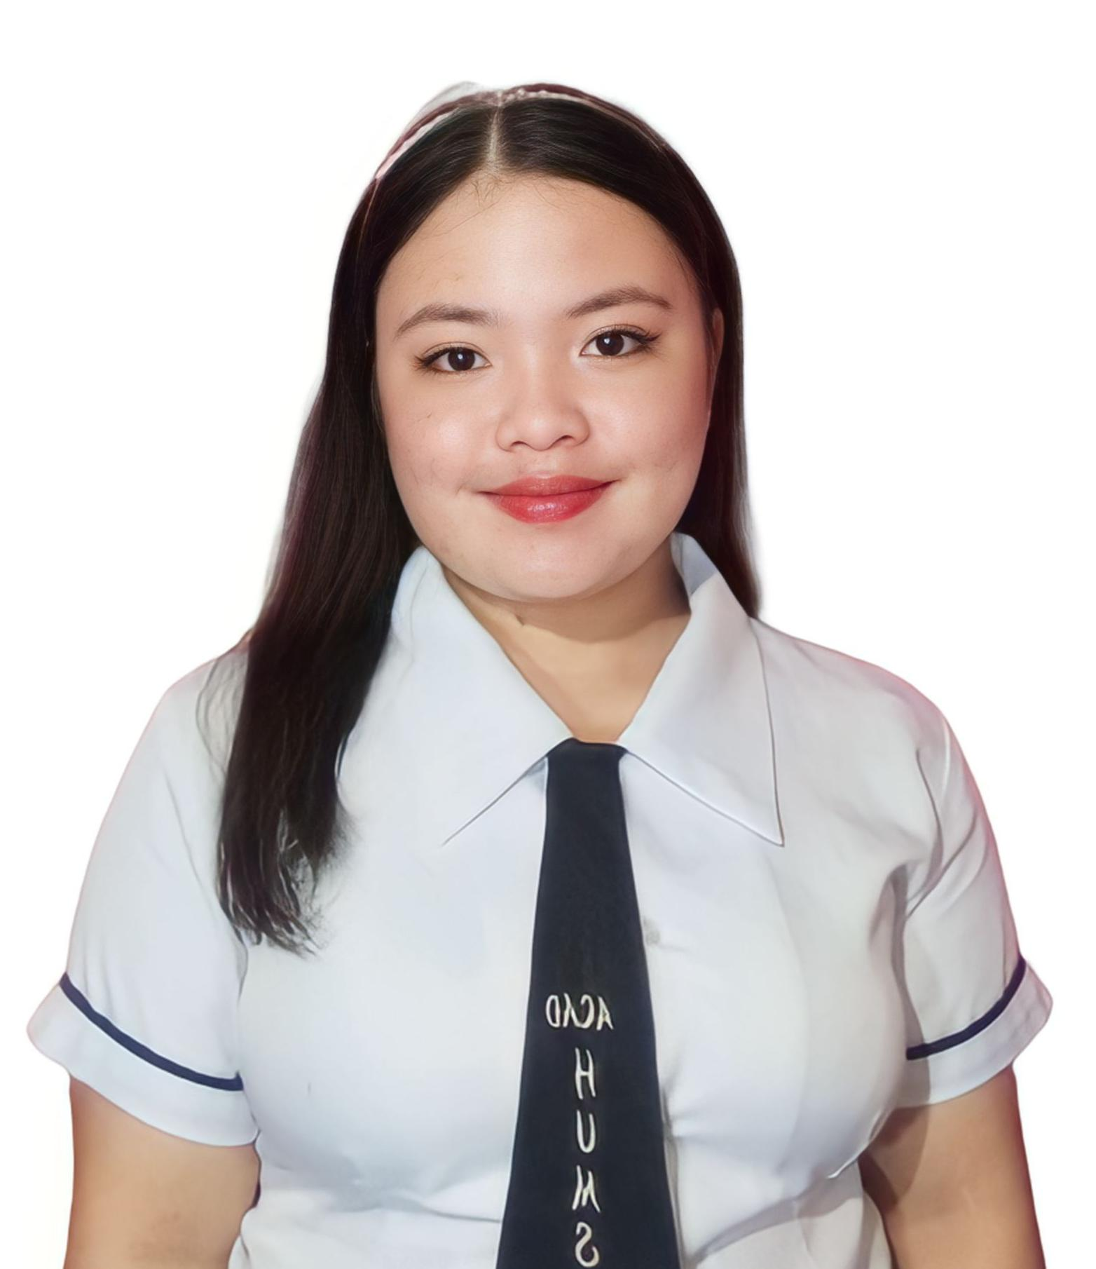

Name: **JUDELYN F.**

**CARTICIANO**

Date of Birth: March 09, 2005

Place of Birth: Tagum, Davao Del Norte

Email Address: [judelyncarticiano09@gmail.com](mailto:judelyncarticiano09@gmail.com)

Father: William A. Carticiano

Mother: Ester F. Carticiano

**EDUCATIONAL** *STRAND:* **Humanities and Social Sciences**

**BACKGROUND** Isulan National High school

Kalawag II, Isulan, Sultan Kudarat

S.Y. 2022-Present

HIGH SCHOOL: Isulan National High School

Kalawag II, Isulan, Sultan Kudarat

2018-2022

ELEMENTARY: Don Juan P. Garcia Senior Memorial

Elementary School, Kenram, Isulan,

Sultan Kudarat

2012-2018

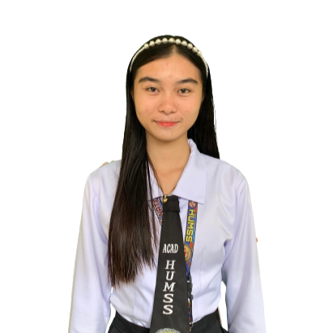

**PERSONAL DATA:**

Name: **TRIXIE VELL B.**

**DALAGON**

Date of Birth: September 14, 2006

Place of Birth: Tamundong Esperanza, Sultan Kudarat

Email Address:

dalagontrixievell@gmail.com

Father: Ernesto G. Dalagon Jr.

Mother: Joan B. Dalagon

**EDUCATIONAL** *STRAND:* **Humanities and Social Sciences**

**BACKGROUND** Isulan National High School

Kalawag II, Isulan, Sultan Kudarat

S.Y. 2022-Present

HIGH SCHOOL: Isulan National High School

Kalawag II, Isulan, Sultan Kudarat

2018-2022

ELEMENTARY: Don Juan P. Garcia Senior Memorial

Elementary School, Kenram, Isulan,

Sultan Kudarat

2012-2018

# 

**PERSONAL DATA:**

Name: **JOHANNA M.**

**MODAY**

Date of Birth: January 13, 2006

Place of Birth: Malatimon Ampatuan, Maguindanao

Email Address: johannamoday13@gmail.com

Father: Datukan M. Moday

Mother: Nida M. Moday

**EDUCATIONAL** *STRAND:* **Humanities and Social Sciences**

**BACKGROUND** Isulan National High School

Kalawag II, Isulan, Sultan Kudarat

S.Y. 2022-Present

HIGH SCHOOL: Isulan National High School

Kalawag II, Isulan, Sultan Kudarat

2018-2022

ELEMENTARY: Kalawag Central School

Kalawag I, Isulan, Sultan Kudarat

2012-2018

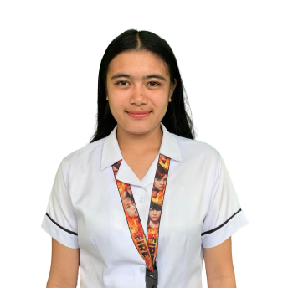

**PERSONAL DATA:**

Name: **AICY JANE B. BAÑO**

Date of Birth: February 22, 2006

Place of Birth: Baras, Tacurong City

Email Address:

aicyjanebano@gmail.com

Father: Joel L. Baño

Mother: Meriam B. Baño

**EDUCATIONAL** *STRAND:* **Humanities and Social Sciences**

**BACKGROUND** Isulan National High School

Kalawag II, Isulan, Sultan Kudarat

S.Y. 2022-Present

HIGH SCHOOL: Isulan National High School

Kalawag II, Isulan, Sultan Kudarat

2018-2022

ELEMENTARY: Villa Clara Elementary School

Sampao, Isulan, Sultan Kudarat

2012-2018

# 

**PERSONAL DATA:**

Name: **BERNADETTE P.**

**USMAN**

Date of Birth: December 12, 2003

Place of Birth: Maitum, Sarangani Province

Email Address:

Bernadetteusman12gmail.com

Father: Bernie M. Usman

Mother: Maricel P. Usman

**EDUCATIONAL** *STRAND:* **Humanities and Social Sciences**

**BACKGROUND** Isulan National High School

Kalawag II, Isulan, Sultan Kudarat

S.Y. 2022-Present

HIGH SCHOOL: Isulan National High School

Kalawag II, Isulan, Sultan Kudarat

2018-2022

ELEMENTARY: Baranggay Upo Elementary School,

Maitum, Sarangani

2012-2018

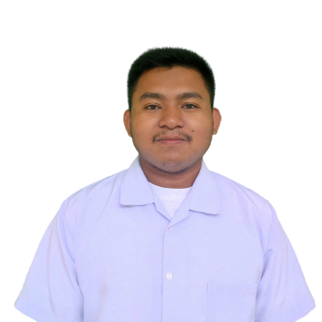

**PERSONAL DATA:**

Name: **RYAN JAMES**

**B. DELIM**

Date of Birth: July 05, 1998

Place of Birth: Kalawag I, Isulan Sultan Kudarat

Email Address:

RJDelim@gmail.com

Father: Rogie C. Delim

Mother: Rebecca J. Delim

**EDUCATIONAL** *STRAND:* **Humanities and Social Sciences**

**BACKGROUND** Isulan National High School

Kalawag II, Isulan, Sultan Kudarat

S.Y. 2022-Present

HIGH SCHOOL: Tupi National High School

South Cotabato

2022-2023

ELEMENTARY: Kalawag Central School

Kalawag I, Isulan, Sultan Kudarat

2004-2010

# 

**PERSONAL DATA:**

Name: **JASON D. RAVIN**

Date of Birth: January 03, 2005

Place of Birth: Wao, Lanao Del Sur

Father: Gerry C. Ravin

Mother: Rocelyn D. Ravin

**EDUCATIONAL** *STRAND:* **Humanities and Social Sciences**

**BACKGROUND** Isulan National High School

Kalawag II, Isulan, Sultan Kudarat

S.Y. 2022-Present

HIGH SCHOOL: Isulan National High School

Kalawag II, Isulan, Sultan Kudarat

2018-2022

ELEMENTARY: Cabayangan Elementary School

Division of Davao Del Norte,

District of Braulio E. Dujali

2012-2018

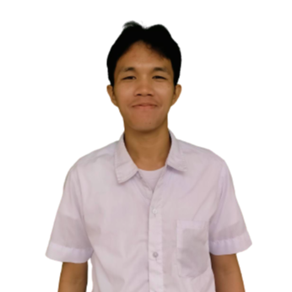

**PERSONAL DATA:**

Name: **JOVER F.**

**POBLACION**

Date of Birth: April 02, 2004

Place of Birth: Kalawag I, Isulan,

Sultan Kudarat

Email Address:

joverpoblacion@gmail.com

Father: Ensoy A. Poblacion

Mother: Virgie F. Poblacion

**EDUCATIONAL** *STRAND:* **Humanities and Social Sciences**

**BACKGROUND** Isulan National High School

Kalawag II, Isulan, Sultan Kudarat

S.Y. 2022-Present

HIGH SCHOOL: Isulan National High School

Kalawag II, Isulan, Sultan Kudarat

2018-2022

ELEMENTARY: Kalawag Central School

Kalawag I, Isulan, Sultan Kudarat

2012-2018

# 

**PERSONAL DATA:**

Name: **ALJIDEL T.**

**SAHIOL**

Date of Birth: December 22, 2004

Place of Birth: Kalawag II, Isulan,

Sultan Kudarat

Email Address:

aljudeltalipasansahiol42@gnail.com

Father: Abdil Hasim T. Sahiol

Mother: Badria T. Sahiol

**EDUCATIONAL** *STRAND:* **Humanities and Social Sciences**

**BACKGROUND** Isulan National High School

Kalawag II, Isulan, Sultan Kudarat

S.Y. 2022-Present

HIGH SCHOOL: Isulan National High School

Kalawag II, Isulan, Sultan Kudarat

2018-2022

ELEMENTARY: PC Bayanihan Elementary School

Kalawag II, Isulan, Sultan Kudarat

2012-2018

# 

**PERSONAL DATA:**

Name: **CLARK JAKE A.**

**GILSANA**

Date of Birth: December 02, 2005

Place of Birth: Kalawag II, Isulan,

Sultan Kudarat

Father: Brignoli L. Gilsana

Mother: Analiza F. Gilsana

**EDUCATIONAL** *STRAND:* **Humanities and Social Sciences**

**BACKGROUND** Isulan National High School

Kalawag II, Isulan, Sultan Kudarat

S.Y. 2022-Present

HIGH SCHOOL: Isulan National High School

Kalawag II, Isulan, Sultan Kudarat

2018-2022

ELEMENTARY: Isulan Central School Sped Center

Kalawag II, Isulan, Sultan Kudarat

2012-2018

**APPENDIX G**

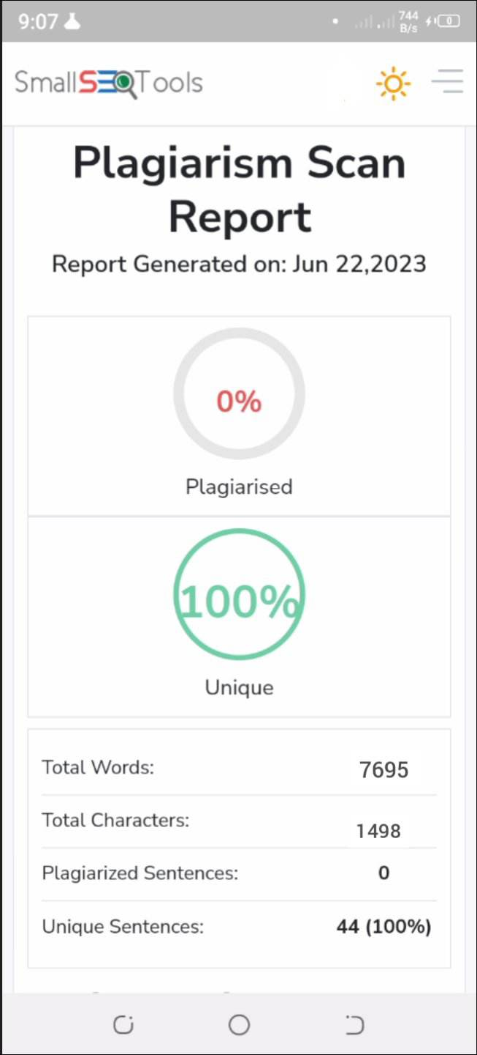**Plagiarism Result**